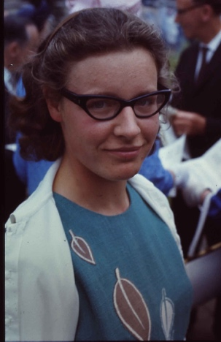
Jocelyn Bell Burnell
Visiting Professor of Astrophysics at the University of Oxford
Fellow of Mansfield College
President of the Institute of Physics
B.S., Natural Philosophy (Physics) – University of Glasgow, Scotland, 1965
Ph.D., Radio Astronomy, University of Cambridge, 1969
Biography
Jocelyn Bell Burnell was born on July 15, 1943 in Belfast, Northern Ireland. Her father was an architect for the Armagh Observatory in Northern Ireland. Her interest in astronomy was fostered at a young age, spending a lot of time with the staff of the observatory. She went on to Lurgen College then graduated from Glasgow University with a degree in Physics. She received her Ph.D. at the University of Cambridge, where she studied interplanetary scintillation of compact radio sources. It was at the University of Cambridge that she discovered Pulsars.
Soon after her discovery, she married Martin Burnell (divorced 1993) whose job took them all over England. She decided to work part time while also raising their son, Gavin Burnell. She went on to hold a Junior Teaching Fellowship at the University of Southampton where she developed a 1-10 million electron volt gamma-ray telescope. She has held research and teaching positions in x-ray astronomy at Mullard Space Science Laboratory, studied infrared astronomy in Edinburgh, and was chosen as fellow of the Royal Astronomical Society where she also served as the Vice President. Burnell is currently a Visiting Professor of Astrophysics as the University of Oxford, a Fellow of Mansfield College, and the current President of the Institute of Physics.
Research Description:
Jocelyn Bell Burnell’s most notable accomplishment is the discovery of Pulsars. She was working as a research assistant at the time, studying under astronomers Antony Hewish (her thesis advisor) and Martin Ryle at the University of Cambridge. She helped to create and operate a 81.5 megahertz radio telescope. In 1967, she was analyzing the miles of print-outs from the telescope when she saw unusual signals she termed “bits of scruff”. This “scruff” indicated radio signals that were different than any other signal they, or any other researchers had seen before. After many months of ruling out all possible sources, the team realized that the signals were made by neutron stars. Neutron stars are rapidly spinning, super-dense, collapsed stars. The media named the stars Pulsars.
Awards, Honors, & Special Recognitions
- Beatrice M. Tinsley Price from American Astronomical Society in 1987
- Herschel Medal from Royal Astronomical Society in 1989
- Oppenheimer Prize
- Michelson Medal
Information on this biography was taken from http://www.biography.com/news/famous-female-scientists, https://www.britannica.com/biography/Jocelyn-Bell-Burnell, and Wikipedia.

