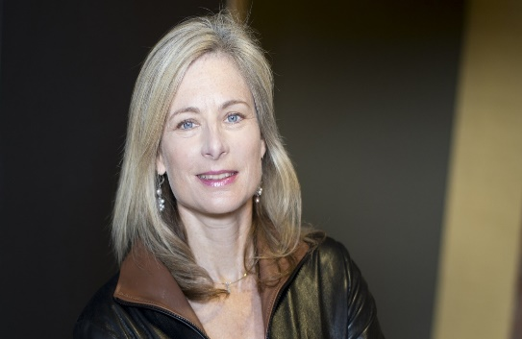
Harvard University

LISA RANDALL

Frank B. Baird, Jr., Professor of Science

Biography
Lisa Randall (born June 18, 1962) is an American theoretical physicist working in particle physics and cosmology. Randall was born in Queens, New York. She is an alumna of Hampshire College Summer Studies in Mathematics and graduated from Stuyvesant High School in 1980, where she was a classmate of fellow physicist and science popularizer Brian Greene. She won first place in the 1980 Westinghouse Science Talent Search at the age of 18.
Randall earned both a B.A. in physics (1983) and a Ph.D. in theoretical particle physics (1987) at Harvard University under Howard Georgi. She is the Frank B. Baird, Jr. Professor of Science on the physics faculty of Harvard University. Randall studies multiple universes. In 2007 she was named one of the 100 most influential people by Time. She has recently written a book called Dark Matter and the Dinosaurs. Randall’s studies have made her among the most cited and influential theoretical physicists and she has received numerous awards and honors for her scientific endeavors
Research
Her research includes elementary particles, fundamental forces and extra dimensions of space. She studies the Standard Model, supersymmetry, possible solutions to the hierarchy problem concerning the relative weakness of gravity, cosmology of extra dimensions, baryogenesis, cosmological inflation, and dark matter. She contributed to the Randall–Sundrum model, first published in 1999 with Raman Sundrum. Her research connects theoretical insights to puzzles in our current understanding of the properties and interactions of matter. She has developed and studied a wide variety of models to address these questions, the most prominent involving extra dimensions of space.
In other words, what we know and see makes up about 4 percent of the universe, Randall researches the other 96 percent of what makes up our universe, dark matter and dark energy.
Awards, Honors, & Special Recognition
- Andrew Gemant Award, 2012
- Lilienfeld Prize, 2007
- E.A. Wood Science Writing Award, 2007
- Klopsted Memorial Award from the American Association of Physics Teachers (AAPT), 2006
- Premio Caterina Tomassoni e Felice Pietro Chisesi Award, from the Sapienza University of Rome, 2003
- National Science Foundation Young Investigator Award, 1992
- Alfred P. Sloan Foundation Research Fellowship
Information on this biography from https://www.physics.harvard.edu/people/facpages/randall at Harvard Faculty Pages and Wikipedia.

