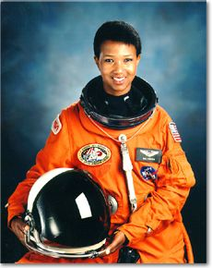
Mae C. Jemison

First black female in space

Astronaut Endeavour mission STS47, 1992

Founder and President, The Dorothy Jemison Foundation

Bachelor of Science degree in chemical engineering Stanford University, 1977
Medical Doctor, Cornell University Medical College, 1981

Biography
Mae Jemison was born on October 17, 1956, in Decatur, Alabama, the youngest child of Charlie Jemison, a roofer and carpenter, and Dorothy (Green) Jemison, an elementary school teacher. Mae attended secondary school at Morgan Park High School, and graduated in 1973 as a consistent honor student. Upon graduating, she attended Stanford University on a National Achievement Scholarship were she achieved a Bachelor of Science degree in chemical engineering from the university in 1977. Shortly after graduating, she entered Cornell University Medical College and obtained her medical doctor degree in 1981. She interned at Los Angeles County/University of Southern California Medical Center and later worked as a general practitioner. June 4, 1987, she became the first African-American woman to be admitted into the astronaut training program. After more than a year of training at NASA, she became the first African-American female astronaut, earning the title of science mission specialist. Mae flew into space on September 12, 1992, with six other astronauts aboard the Endeavour on mission; she became the first African-American woman in space. She left the astronaut corps in March 1993, and then accepted a teaching fellowship at Dartmouth. Mae also established The Dorothy Jemison Foundation, a company that seeks to research, develop and market advanced technologies.

Research
During her eight days in space, she conducted experiments on weightlessness and motion sickness on the crew and herself. In all, she spent more than 190 hours in space before returning to Earth on September 20, 1992. Following her historic flight, Jemison noted that society should recognize how much both women and members of other minority groups can contribute if given the opportunity.

Awards, Honors, & Special Recognitions
- Doctorate, Essence Science and Technology Award 1988
- Doctorate, Ebony Black Achievement Award in 1992
- Doctorate, Montgomery Fellowship from Dartmouth College in 1993
- Gamma Sigma Gamma Woman of the Year in 1990
- Mae C. Jemison Academy was named after her 1992

Information on this biography was taken from her biography at http://www.biography.com/people/mae-c-jemison-9542378#synopsis

