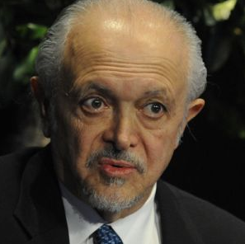
Mario Molina
Physical Chemistry at the University of California, Berkeley
Professor at the University of California, San Diego, Center for Atmospheric Sciences at the Scripps Institution of Oceanography
B.S., Chemical Engineering National Autonomous University of Mexico, 1965 M.S., Albert Ludwig University of Frieberg, 1967 Ph.D., Chemistry-University of California, Berkeley 1972

Biography
Mario Molina born, March 19, 1943, knew as a child he loved science. When Mario was very young he turned his own bathroom into a chemistry lab using toy microscopes and chemistry sets. Molina is the son of Roberto Molina-Pasquel, a lawyer, judge and chief Ambassador to Ethiopia, Australia, and the Philippines, and Leonor Henriquez. Mario Molina had an Aunt Esther who he looked up to, who helped him with his experiments and was a chemist.
Mario completed his studies in Mexico City at the Institute Rosenberg in Switzerland. He received a bachelor's degree in chemical engineering at the National Autonomous University of Mexico (UNAM) in 1965. Two years later he earned his postgraduate degree at the Albert Ludwig University of Freiburg, West Germany. Finally, he earned a Ph.D. in chemistry at the University of California, Berkeley in 1972. Molina married chemist Luisa Y. Tan in July 1973 and moved to California.
Research
Mario Molina joined the lab of Professor F. Sherwood Rowland in 1973. Molina continued Rowland's pioneering research into "hot atom" chemistry, which is the study of chemical properties of atoms with, and only with, excess translational energy owing to radioactive processes. This study soon led to research into chlorofluorocarbons (CFCs), which had been accumulating in the atmosphere. Rowland and Molina developed the CFC ozone depletion theory. Molina tried to figure out how CFCs might be destroyed in the lower atmosphere, but nothing seemed to work. They knew that if CFCs released into the atmosphere do not decay by other processes, they continually rise to higher altitudes until they are destroyed by solar radiation. They discovered that chlorine atoms, produced by the decomposition of CFCs, catalytically destroy ozone. The findings was published in Nature on June 28, 1974.
Awards, Honors, & Special Recognitions
- 1995 Nobel Prize in Chemistry
- 1987 Esselen Award of the Northeast
- 1988 he won the Newcomb-Cleveland
- 1989 NASA Medal for Exceptional Scientific Advancement
- 1989 United Nations Environmental Program Global 500 Award

Information on this biography was taken from Biography, http://biography.com/people/mario-molina and Wikipedia

