Caitlin Gumiela
Culturally Responsive Assignment
February 20, 2017
Mary Leakey
Mary Leakey was an extraordinary woman. She was known as one of the world’s most distinguished fossil hunters. With many discoveries in her field research, there is a lot to learn about this female scientist. Mary attended a few lectures at the University College of London, although she had never earned a degree, but by the end of her life she had received many honorary degrees and other awards.
Mary Douglas Nicol was born on February 6th 1913. At an early age Mary knew she was interested in archaeology. On her many visits to France with her parents, she visited a museum of prehistory and participated in archaeological digs where she found stone tools. Mary excelled at drawing, just like her father did. She used her talent later in life in the field of paleoanthropology. At just seventeen years old, Mary was an illustrator at a dig in England.
In the 1930s, illustrated for the book “Adam’s Ancestors” (1934.) This book was authored by Louis S.B. Leakey, an archaeologist and anthropologist. The two hit it off and soon developed a personal relationship. Mary and Louis go married in 1937, forming one of science’s most well-known husband and wife team. As a couple, they moved to Africa as Louis started an excavation project at the Olduvai Gorge, a ravine in what is now Tanzania.
Mary made her first discovery in 1948. Finding a partial skull fossil of Proconsul africanus, an ancestor of apes and humans that evolved into two distinct species. The finding of this fossil was extraordinary because the fossil was believed to be more than 18 million years old and the first primate genus to be discovered from the Miocene era.
Later, Mary had a part in the unravel of the mystery surrounding the origins of humankind when she found a partial skull of an early human in 1959. The early analyses of the artifact, initially named Zinjanthropus boisei, Charles Boysey (known as Astralopithecus boisei now,) showed that the species had small brain but massive teeth, jaws, and muscles so large that they had to be anchored to a ridge at the top of the skull. It was later determined that Zinjanthropus boisei was nearly 2 million years old. In 1960, the husband and wife team made their next major discovery. The couple discovered fossils of homo habilis, a species that is believe to between 1.4 and 2.3 million years old and have originated during the Gelasian Pleistocene period. This discovery provided evidence that the species were skilled in making stone tools which makes them the earliest known experts.
After Mary’s husband passed away in 1972, she continued to research and hunt for fossils. In 1979, Mary made an amazing discovery of a well-preserved 89-foot long trail of early human footprints found at Laetoli. This was the first in the history of science to provide direct evidence of physical activity by humankind’s apelike ancestors, changing previously held assumptions about primates. Mary was funded throughout her decades-long career by the National Geographic Society and many grants. She shared her experiences of her career in a book in 1979 “Olduvai Gorge: My Search for Early Man” as well as an autobiography in 1984, “Disclosing the Past.”
Mary Leakey died December 9th 1996 in Nairobi, Kenya. She has three sons with her deceased husband; Richard, Johnathan, and Philip. Today, Mary’s work continues through both the Leakey Foundation and the younger generations of the Leakey family carrying on her legacy.

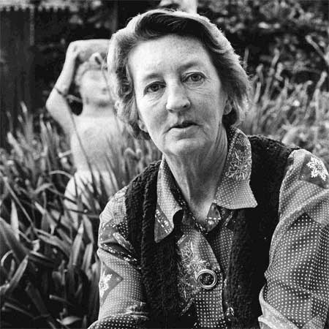 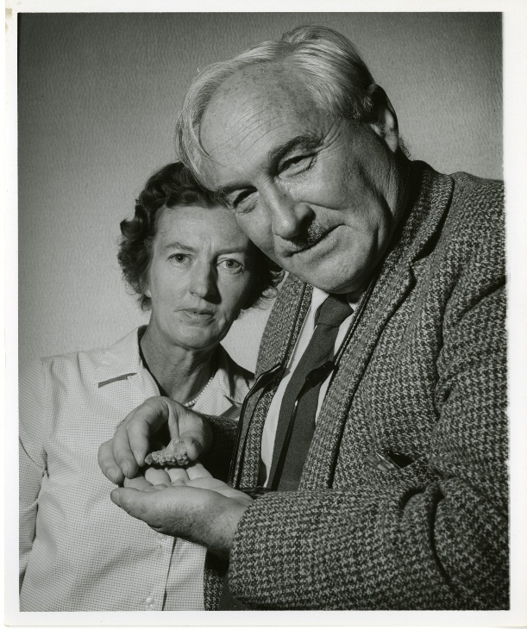http://blog.yovisto.com/wp-content/uploads/2015/08/left_to_right_Mary_Douglas_Nicol_Leakey_1913-1996_and_her_husband_Louis_Seymour_Bazett_Leakey_1903-1972.jpg
http://cdn.quotationof.com/images/mary-leakey-2.jpg
http://www.leakey.com/bios/mary-leakey
http://www.biography.com/people/mary-leakey-9376051

