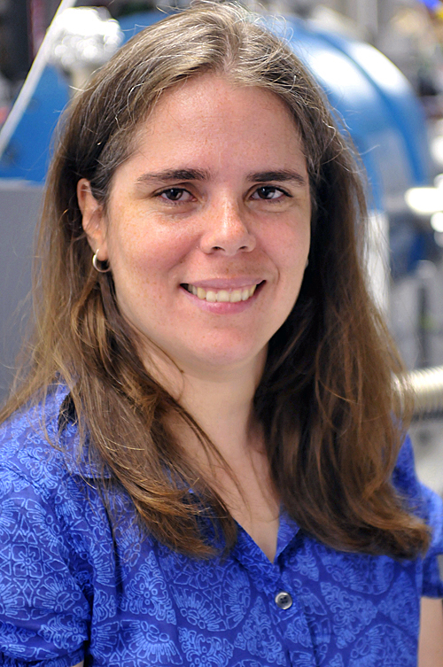
Mayly Sánchez
Born June 26, 1972 in Caracas, Venezuela
Universidad de Los Andes, Mérida Venezuela B.S. in Physics, 1995
One-year Postgraduate Diploma Programme at the Abdus Salam International Centre for Theoretical Physics in High Energy Physics in Trieste Italy, 1996
Tufts University, Boston Massachusetts, M.Sc. in Physics, 1998
Tufts University, Boston Massachusetts, Ph.D. in Physics, 2003

Mayly Sanchez was born in Caracas, Venezuela and later grew up in Merida, Venezuela. When she was a young girl, she was very interested in computers. When the TV series “Cosmos” by Carl Sagan premiered, she became passionate about astronomy. She asked for books about astronomy for her birthday presents when she was 12 years old. Her uncle, who is a priest, told her if she wanted to know more about astronomy, she would need to study physics. As time passed, her focus switched from astronomy to physics. Sanchez says that her early science education was mostly just memorizing “a long collection of facts”. Her most influential teachers were her high school math teacher and her high school physics teacher. She attended an all-girls private Catholic school, these teachers inspired her and helped her to continue to pursue her interests in physics.
She then went on to study physics at the university in Merida, Venezuela. It was here where her interest in astronomy and physics began to focus more specifically on fundamental particles. Her sister pursued a career in the arts, so her family described them as having a duality of the artist and the scientist. It was not until graduate school that Sanchez began to think of herself as a bonafide scientist. She completed a one-year program at the Abdus Salam International Centre for Theoretical Physics in High Energy Physics in Trieste Italy, then began a Ms.C./Ph.D. program at Tufts University in Boston, Massachusetts. It was during her graduate study at Tufts when Sanchez became interested in neutrinos, which has become her research focus to this day. Her doctoral dissertation was titled “Oscillation Analysis of Atmospheric Neutrinos in Soudan 2”. After she graduated with her doctorate degree, she worked for four years as a postdoctoral fellow at Harvard University where she continued working in experimental physics focused on fundamental particles, particularly neutrinos. She then began working at the Argonne National Laboratory in Lemont Illinois while also teaching and advising at Iowa State University. In 2011, she was honored with the Presidential Early Career Award for Scientists and Engineers (PECASE) from President Obama "for contributions to the detection and study of neutrinos and their role in some of the most fundamental problems in physics, and for reaching out to potential women STEM majors and exciting them about opportunities in the STEM fields, in particular physics and astronomy.". Sanchez is involved with the NOvA Neutrino Experiment, the Deep Underground Neutrino Experiment (DUNE), and is one of the founders and head physicists of the Accelerator Neutrino Neutron Interaction Experiment or ANNIE, which she says is the accomplishment she is most proud of to date.

Research Area: Neutrino Physics
When the average non-scientist thinks about the parts of atom, electrons, neutrons, and protons are what typically come to mind. Experimental physicists over the course of the past century or so however have proven that that is a overly simplified concept of elementary particles. Sanchez says that when she describes what she does with neutrinos to family members and friends who are not involved in physics, she tells them that she studies a particle that is tiny and that is nearly impossible to study, because it almost never interacts with any matter at all. It takes great lengths to measure the mass. Neutrinos are neutral particles, they have no charge. Neutrinos are one of the leptons (lighter particles). Neutrinos are even lighter than electrons, their mass is so small it seems likely that they are fundamental particles. Neutrinos come from nuclear decay, like a nuclear reactor. As atoms decay and change from one type to another, they generate neutrinos. Nuclear reaction from the sun also create neutrinos, and they can arrive to Earth from the sun. Chain reactions of particles can also create neutrinos. Sanchez’s ANNIE lab uses two beams of neutrinos, in which they accelerate protons and use magnets and various forms of electricity to accelerate them. They shoot protons against graphite, which produces a lot of particles and a lot of neutrinos. This allows them to study neutrinos that they produce and control the intensity of, allowing ANNIE to detect a few neutrinos each day. The neutrinos are lower energy than neutrinos produced ‘naturally’ like those studied in a lab in Antarctica, but they can study the properties of the neutrinos better at the ANNIE lab. It is still unknown how many neutrinos come out of the interactions, so that is part of what the experiment is trying to determine. Neutrinos are a popular research topic currently in experimental physics because it allows physicists to learn more about matter at its most fundamental level.

