Name: Neil Degrasse Tyson Photo:
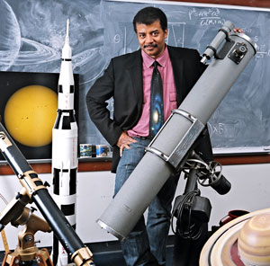
Birthdate: October 5th, 1958 Date of Death: N/A
Degrees conferred: 19 honorary doctorates, BA and PHD in Astrophysics
Biographical essay: His memoir “The Sky is Not the Limit: Adventures of an Urban Astrophysicist”
Research description: Studies involving star formation, exploding stars, dwarf galaxies, and the structure of our Milky Way.

Bibliography
http://www.haydenplanetarium.org/tyson/profile/about-neil-degrasse-tyson
http://www.biography.com/people/neil-degrasse-tyson-20766239

Neil Degrasse Tyson grew up in New York City. He had a love for stars since he was a young boy. He took his first trip to the Hayden Planetarium when he was 9 and thus began his passion for stargazing. He took classes at the Planetarium. Once he got his first telescope, he began stargazing the night skies from his apartment building. He became a director at the Planetarium and began doing renovations on the Planetarium. He says that one of his goal is to find ways to bring outer space and the universe down to Earth so that people can better understand it and excite them. Tyson is married and has two children. He attended public school for his education. After high school, he attended Harvard for his BA and Colombia for his PHD in Astrophysics. Tyson’s studies include things involving star formations, exploding stars, dwarf galaxies and the structure of the Milky Way. He was appointed by President Bush to be on a committee and study Aerospace industry and its future. He worked to find ways to promote a thriving future of transportation, space exploration and national security. He was also approached by Bush again to be on another committee to work on the implementation of the United States Space Exploration Policy. This was later named “Moon, Mars and Beyond”. Along with being an astrophysicist, Tyson has also dine some work with writing. He has written both professionally and publicly. He has written for National History magazine and wrote approximately 10 books. Tyson is also very popular for his hosting of the popular show NOVA ScienceNOW. This show explores and shapes our knowledge of the universe. His first year on television, he was nominated for an Emmy. Tyson also hosted a show called “Cosmos: A Space Time Odyssey. This show was awarded 4 Emmys, a Peabody Award, 2 Critics Choice awards and many other recognitions. Tyson was awarded the NASA Distinguished Public Service Medal. This award is known to be the highest known award for someone not in the government to be given by NASA. The International Astronomical Union names an asteroid after him “13123 Tyson”. People magazine voted Tyson the “Sexiest Astrophysicist Alive”. He is the first person to receive a Frederick P. Rose Directorship. Tyson still works at the Hayden Planetarium. Tyson is known for being able to make difficult concepts easily accessible and understanding to people.

