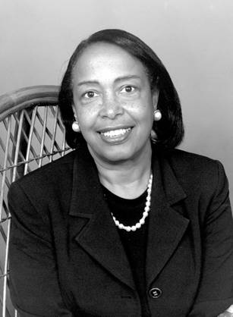
Dr. Patricia Bath
UCLA Ophthalmology Residency Training Program Chair
Inventor of the Laserphaco Probe – 1986-1988

Residency: New York University
Fellowship: Columbia University
Ph. D. Howard University College of Medicine
B.A. Hunter College in New York
High School: Charles Evans Hughes in New York

Biography:
Patricia Bath was born on November 4, 1942 in Harlem, New York. Born amidst World War II, the future for a child of color was still uncertain but Patricia surged forward. Her father, Rupert, was the first black motorman for the New York City Subway, a journalist and a merchant seaman who travelled the world. Most importantly, however, he was the perfect role model for his aspiring daughter. Patricia’s mother, Gladys, was a driven individual as well as she was a housewife who saved money for Patricia’s future education.
Before Patricia got to high school, her parents realized her growing curiosity for science and bought her a chemistry set. In high school, at the age of 16, she was selected to attend a summer program at Yeshiva University where she studied cancer research. From this opportunity, she created a mathematical equation to calculate the growth rate of cancer. Also, from this research, sparked her first award, the Merit Award in 1960. In turn, she graduated high school early to attend Hunter College in New York, then went to Howard University for Medical School. During this time, she went to Yugoslavia to study pediatrics before graduating in 1968.
During her fellowship at Columbia University, she noticed that the black and poor population of Harlem did not receive proper eye care, therefore leading to more cases of cataracts and glaucoma. She started eye care clinics for such people and continued to research ophthalmology. From here, she was the first African American to complete a residency in ophthalmology at New York University.
Research:
Although her research at the age of 16 is impressive, her biggest achievement was her invention called the “Laserphaco Probe.” This invention created a new way to remove cataracts that was less invasive and quicker than the original way. Her advancements in the fields of medicine and laser technology has helped thousands and is still the leading procedure for patients today. Her invention surpassed expectations as it helped patients see again. One case was a patient who was blind for 30 years! At first, her design blueprint was perfected but she could not get the lasers needed in the United States as they were reserved for military purposes. In order to avoid this obstacle, she travelled to British Columbia to finish the design. Immediately after she got a patent in a few different countries and started to help people see again.

Awards:
- 1960 – Merit Award from Mademoiselle Magazine
- 1988 – Inducted into Hunter College “Hall of Fame”
- 1993 – Howard University Pioneer in Academic Medicine

Information on this biography was taken from https://cfmedicine.nlm.nih.gov/physicians/biography_26.html and biography.com

