Name: Peggy A. Whitson (Ph. D.) NASA Astronaut
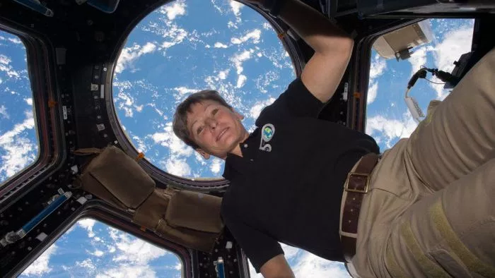
Birthdate: Born February 9, 1960, in Mt. Ayr, Iowa. Hometown is Beaconsfield, Iowa. Married to Clarence F. Sams, Ph.D.
Degrees conferred (location and dates): Graduated from Mt. Ayr Community High School, Mt. Ayr, Iowa, in 1978; received a Bachelor of Science in Biology/Chemistry from Iowa Wesleyan College in 1981 and a Doctorate in Biochemistry from Rice University in 1985.
Research area : Following her fellowship at Rice, she began working at Johnson Space Center in Houston, Texas, as a National Research Council Resident Research Associate. From April 1988 until September 1989, Whitson served as the Supervisor for the Biochemistry Research Group at KRUG International, a medical sciences contractor at NASA.
From 1991 through 1997, Whitson was invited to be an adjunct assistant professor in the Department of Internal Medicine, and Department of Human Biological Chemistry and Genetics at the University of Texas Medical Branch in Galveston, Texas. In 1997, Whitson began a position as adjunct assistant professor at Rice University in the Maybee Laboratory for Biochemical and Genetic Engineering
Biographical essay: Peggy Annette Whitson is an American biochemist and astronaut who holds the record for most total days spent in space by any NASA astronaut. She is also the first woman astronaut to command the International Space Station twice. Ambitious from a young age, she realized her life’s calling quite early on. As a nine-year-old, she watched Buzz Aldrin and Neil Armstrong walk on the moon on her TV and decided to become an astronaut herself. The year Whitson graduated from school, Sally Ride was named as the first female American astronaut and that made her resolve stronger. At the age of twenty-six, she joined the Johnson Space Center at NASA as a National Research Council Resident Research Associate. Ten years later, she was selected as an Astronaut Candidate and underwent two years of rigorous training. Finally, her dream came true when she, as a part of Expedition 5 crew, launched aboard STS-111 for the International Space Station on June 5, 2002. She made a second trip to the space in October 2007; this time as a commander. In fact, she is the first female commander to lead any space exploration. In April 2017, Whitson surpassed astronaut Jeff Williams’ previous record of 534 days, 2 hours, and 48 minutes of cumulative time in space by a NASA astronaut by creating a new record of more than 534 days.
Research description: From 1989 to 1993, Dr. Whitson worked as a Research Biochemist in the Biomedical Operations and Research Branch at NASA’s Johnson Space Center. From 1991 to 1993, she served as Technical Monitor of the Biochemistry Research Laboratories in the Biomedical Operations and Research Branch. From 1991 to 1992, she was the Payload Element Developer for the Bone Cell Research Experiment (E10) aboard SL-J (STS-47) and was a member of the U.S.-USSR Joint Working Group in Space Medicine and Biology. In 1992, she was named the Project Scientist of the Shuttle-Mir Program (STS-60, STS-63, STS-71, Mir 18, Mir 19) and served in this capacity until the conclusion of the Phase 1A Program in 1995. From 1993 to 1996, Whitson held the additional responsibilities of the Deputy Division Chief of the Medical Sciences Division at Johnson Space Center
Awards and Honors: Inducted into Iowa Aviation Hall of Fame (2011); BioHouston Women in Science Award (2011); Houston’s 50 Most Influential Women of 2011; Russian Medal of Merit for Space (2011); Texas Women on the Move award recipient (2010); Distinguished Alumni Award, Rice University (2010); NASA Space Flight Medal (2002, 2008); First Lady of Iowa Award presented by the Iowa High School Girls’ Athletic Union (2010); Iowa Transportation Museum, Hero of Valor (2009); Lion’s Club Mount Ayr Elementary Science Lab dedication, Peggy Whitson Science Center (2008); NASA Outstanding Leadership Medal (2006); Distinguished Alumni Award, Iowa Wesleyan College (2002); two patents approved (1997, 1998); Group Achievement Award for Shuttle-Mir Program (1996); American Astronautical Society Randolph Lovelace II Award (1995); NASA Tech Brief Award (1995); NASA Space Act Board Award (1995, 1998); NASA Silver Snoopy Award (1995); NASA Exceptional Service Medal (1995, 2003, 2006, 2008); NASA Space Act Award for Patent Application; NASA Certificate of Commendation (1994); Selected for Space Station Redesign Team (March to June 1993); NASA Sustained Superior Performance Award (1990); Krug International Merit Award (1989); NASA JSC National Research Council Resident Research Associate (1986 to 1988); Summa Cum Laude from Iowa Wesleyan College (1981); President’s Honor Roll (1978 to 1981); Orange van Calhoun Scholarship (1980); State of Iowa Scholar (1979); Academic Excellence Award (1978).

