Stephanie Kwolek 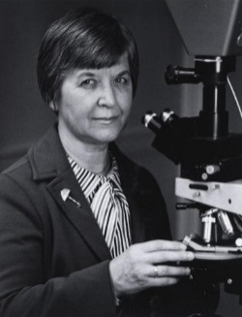
Headed polymer research at DuPont's Pioneering Lab until her retirement in 1986
BS in Chemistry, Carnegie Mellon University, 1946
Biography
Stephanie Kwolek was born in New Kensington, Pennsylvania in 1923. She developed a love of fabrics and sewing from her mother, a homemaker. She was also interested in Science and had plans to go to medical school. She graduated with a BS in Chemistry from Carnegie Mellon University in 1946. She couldn’t afford medical school so she took a position with DuPont and her work was so interesting, she decided to stay there.
Research
Stephanie Kwolek was one of the first women research chemists and first gained national recognition in 1960 for her work with long molecule chains at low temperatures. After nine years of research work, she made her major breakthrough, discovering Kevlar. Her road to discovery began a year earlier, when she was looking for a new, lightweight plastic to be used in car tires. The idea was that lighter tires would allow vehicles to enjoy better fuel economy.
Not only did Kevlar find use in tires, its combination of lightness and strength has seen it used in a large variety of protective clothing applications, such as bulletproof vests, which have saved the lives of countless police officers and others and has been used in spacecraft too. In 1971, when she discovered the liquid crystalline polymer solution, that is what led to this great discovery. Kevlar is a synthetic material than is five times as strong as steel.
Stephanie Kwolek led polymer research at DuPont's Pioneering Lab until her retirement, in 1986. Stephanie passed away on June 18, 2014. She is recipient or co-recipient of 17 US patents.
Awards, Honors, & Special Recognitions
- National Inventors Hall of Fame in 1994
- National Medal of Technology 1999
- Lemelson-MIT Lifetime Achievement Award 1999
- Perkin Medal
- Kilby Award
- National Medal of Technology

