Measurement Manual for the
Biosand Filter Project

Flowrate Measurement Instructions
The flow rate in the BSF is very important. The first time the BSF is used, there is no sticky biolayer to trap particles and bacteria. The flow rate will be high but the treatment will not be adequate. After some time the biolayer will develop, the flow rate will slow down and the water quality will improve. However, as you continue to purify more water, day after day, the biolayer will grow, the BSF will become clogged and the flow rate will get very slow. At this point it will take so much time to collect water from the BSF that it will be unacceptable to the users. It will be time to clean the BSF using the swirl and dump method. A stick can be used to agitate the biolayer and dirty water is scooped out of the top. Be careful not to disturb the sand layer itself. After cleaning, the biosand filter can be operated as usual. You should see the flow rate improve but the water quality might degrade for a few days. An acceptable flow rate for the model BSF is 20-30 mL/min. A real BSF is much larger than your model so the flow rate will be higher.

Tools | Jobs
- Watch/phone  - 250 mL Graduated Cylinder  - Container | - Time Keeper  - Pourer  - Collector  - Recorder

- The Time Keeper gets a timer ready on a phone or watch.
- The Collector gets ready with the graduated cylinder at the outlet of the BSF.
- The Pourer slowly pours the water into the top of the BSF through the diffuser plate.
- When the water is at its highest level in the BSF, the Collector begins collecting the water that comes out of the outlet tube and the Time Keeper starts their timer.
- Continue to collect water and time until two minutes have passed, then stop collecting water and allow the water to flow out of the biosand filter into the container.
- The Recorder writes down the volume of water collected in 2 minutes on the Flowrate Data Sheet and does the required calculation (Formula shown below).
- Pour the water collected in the 250mL graduated cylinder into the bucket.

Flow Rate Formula
Flow Rate mL/min=Volume of Water Collected (mL)
Time to collect the water (min)

Note - you may need to collect influent and effluent water for your other measurements.
Safety Note: If your untreated water is safe for recreational use (e.g., swimming, wading, fishing) then this test can be done without personal protective equipment (PPE). If the water is contaminated with potential pathogens, students should wear gloves, safety goggles, and lab aprons.

Flow Rate Data Sheet

Name(s): __________________________________________________________
Date: ________________________ Group ___________________
Qualitative analysis
Does the water flow out of the biosand filter at a constant rate?
If it doesn’t, how does the flow change over time?

Quantitative Analysis
Measure the flow rate when the water is as high as it can be in the biosand filter. Use the data chart and the Flow Rate formula to calculate the flow rate.
Flow Rate mL/min=Volume Collected (mL)/time to collect the water (min)
Collection time | Volume  (mL) | Time  (min) | Flow rate (mL/min)
When BSF is at the highest level

Good flow rate: >30 mL/min
Acceptable flow rate 20-30 mL/min
Poor flow rate < 20 mL/min

What should you do to improve the flow rate of the BSF if it is too low?

General Observations of the operation of the BSF:

pH Measurement Using pH Strips
pH is a measurement of how acidic or basic a solution is. The lower the pH the more acidic the water is. The higher the pH the more basic. A pH of 7 is neutral. The US EPA drinking water standards require that water treatment plants maintain a pH between 6.5 and 8.5. Treatment of water in the BSF should not change the pH. If you see a big change in the pH you may have a problem with your measurement method or there is some other problem with the BSF media or BSF construction material.
Materials you need
- Sample of water before it is filtered (influent).
- Sample of water after it is filtered (effluent).
- pH strips.
- Indicator chart on pH strip package.
Instructions
Test the water before it is filtered:
- Place pH strip in water sample for 2 seconds.
- Take the strip out of the sample and wait 10 seconds for color to stabilize.
- Match color on strip with chart on package (at least two students should agree on the color match)
- Write value on your data sheet.
Repeat with the filtered water.

Safety Note: If your untreated water is safe for recreational use (e.g., swimming, wading, fishing) then this test can be done without personal protective equipment (PPE). If the water is contaminated with potential pathogens, students should wear gloves, safety goggles, and lab aprons.

pH Data Sheet

Name(s): __________________________________________________________
Date: ________________________ Group _______________________

Before filtering the water

pH: ________________

After filtering the water

pH: ________________

General Observations of the operation of the BSF:

Secchi Tube Construction
- You will need to cut some 4’ lengths of clear plastic or acrylic tubing. The tubes can be 1-3/8’’Inside Dia. , 1-1/2’’ Outside Dia. and 4’ Length. A photograph of secchi tubes is shown below.
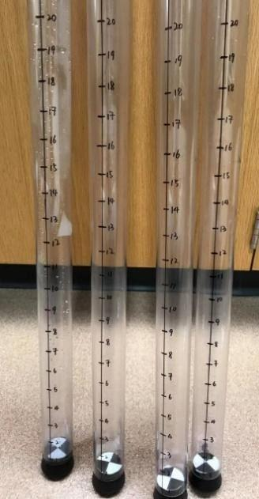

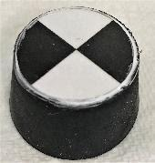

- Mark the length of the tube in inches using a ruler and permanent waterproof marker.
- You will also need to make waterproof secchi disks to stick to the rubber stoppers that are inserted into the bottom of the clear plastic tube. One way to do this is to print out the pattern (see SecchiDisks.jpg in the supplementary materials folder) and sandwich it between two sheets of transparent self adhesive shelf liner (such as Con-Tact paper). Then cut out the correct size disk for your stopper.
- Glue the disk to the top of a size #8 rubber stopper (Dimensions: 1-5/8’’ Top Dia. by 1-5/16’’ Bottom Dia. by 0.987’’ Length).
- When the glue on the rubber stopper is dry, force the rubber stopper into the bottom of the clear plastic tube. Make sure the rubber stopper does not fall out.

Using the Secchi Tube
A secchi tube is used to measure the fine particles in the water, such as bacteria and soil. It is important to remove fine particles from water because they may carry harmful chemicals or bacteria. When you use the secchi tube you add water to the tube until you can no longer see the pattern on the secchi disk. The cloudier (or more turbid) the water the lower the height will be when the pattern on the disk is no longer visible. Turbidity is measured using Nephelometric Turbidity Units (NTU).
- Have one student slowly pour the water into the secchi tube while the other student looks through the water from the top at the black and white secchi disk.
- When the student watching the disk can no longer see the black and white pattern, record the height of the water in the tube (in inches).
- Use the table below to convert the water height in inches to the Turbidity in Nephelometric Turbidity Units (NTU).
Depth (Inches) | Turbidity (NTU) |  | Depth (Inches) | Turbidity (NTU)
1 | 1100 |  | 25 | 6.4
2 | 380 |  | 26 | 6.0
3 | 200 |  | 27 | 5.7
4 | 120 |  | 28 | 5.3
5 | 86 |  | 29 | 5.1
6 | 64 |  | 30 | 4.8
7 | 50 |  | 31 | 4.5
8 | 40 |  | 32 | 4.3
9 | 33 |  | 33 | 4.1
10 | 28 |  | 34 | 3.9
11 | 24 |  | 35 | 3.7
12 | 21 |  | 36 | 3.6
13 | 18 |  | 37 | 3.4
14 | 16 |  | 38 | 3.3
15 | 15 |  | 39 | 3.1
16 | 13 |  | 40 | 3.0
17 | 12 |  | 41 | 2.9
18 | 11 |  | 42 | 2.8
19 | 10 |  | 43 | 2.7
20 | 9.2 |  | 44 | 2.6
21 | 8.5 |  | 45 | 2.5
22 | 7.9 |  | 46 | 2.4
23 | 7.3 |  | 47 | 2.3
24 | 6.9 |  | 48 | 2.2

Safety Note: If your untreated water is safe for recreational use (e.g., swimming, wading, fishing) then this test can be done without personal protective equipment (PPE). If the water is contaminated with potential pathogens, students should wear gloves, safety goggles, and lab aprons.

Turbidity Data Sheet

Name(s): __________________________________________________________
Date: ________________________ Group: __________________

Before filtering the water

Qualitative analysis
How does the water look? (circle one): Very Cloudy Cloudy Almost Clear Very Clear

Quantitative Analysis
Turbidity (NTU): ________________

After filtering the water

Qualitative analysis
How does the water look? (circle one): Very Cloudy Cloudy Almost Clear Very Clear

Quantitative Analysis
Turbidity (NTU): ________________

General Observations of the operation of the BSF:

Coliscan Easygel Instructions
Our team found that Coliscan Easygel Test Kits from Micrology Laboratories Inc. were relatively easy for teachers and students to use to achieve accurate results. However, they are expensive (about $35 for a set of 10 kits). If you are able to measure fecal indicator bacteria by another method, feel free to use your own method. Here’s a link to the Micrology website https://www.micrologylabs.com/page.php?page_id=93&page_name=Coliscan-Easygel.
E. coli are non-harmful bacteria that are in the gut of warm blooded animals, including birds, dogs and cats, and humans. When we go to the bathroom, E. coli are discharged with our feces. E. coli are called “fecal indicator bacteria” because their presence indicates the presence of fecal material, for example if there are a lot of waterfowl in your pond or people are not properly cleaning up after their dogs. E. coli are too small for us to see, so we test for E. coli using the “spread plate method”. We carefully spread a known volume of water on the top of a plate that contains a nutrient solution that E. coli like to grow in along with a gelling agent that is similar to gelatin that is used to make Jello. When an E. coli bacteria falls on the agar plate, it starts to divide by binary fission. One cell becomes two, two becomes four, four becomes eight and finally after incubating the plates for 24 to 48 hours we get a colony that we can see with our naked eyes! By counting the number of colonies and dividing by the initial volume of water we spread on the plate we can know how many E. coli were in the water sample. The BSF should remove E. coli from the water, indicating that it is also being purified to remove harmful bacteria.
Measurement schedule
The E.coli measurements should be done at the end of the third week of BSF operation, the last week of operation, and one more time in between.
Safety
Wear latex gloves, safety glasses and lab aprons when doing Easygel analysis.
Never throw Easygel dishes into the trash. Pour approximately 5 mL of a 10% bleach solution into each plate. Put the disinfected plates in the large Ziploc bag and place them in the trashcan for disposal.
Important Notes
- Easygel must be performed as soon as possible after sample collection! If samples must be kept for over an hour, place them in a refrigerator. If you put samples in the refrigerator, the analysis must still be done within 24 hours after the sample was collected.
- Keep the Easygel bottles frozen until you need to use them.
- All measurements should be done on unfiltered and filtered water.
Materials you need
- Easygel bottles
- Petri dishes
- Pipettes
- Clean beakers (washed in soapy water and rinsed 3 times).
- Incubator (if available)
- Plastic Ziploc bags (for disposal)
- Masking tape
- 10% bleach solution 10 mL of household bleach to 100 mL of tap water.
Instructions
Prepare the media
- Before you can use the media, it must be thawed. Remove the bottles from the freezer and place them in a container of warm water for 10-15 minutes or place them in the room until they are at room temperature
Note: Only thaw the media if you are going to use it within the next hour.
Collect the samples
- Reserve some water (at least 20 mL) in a clean beaker before it goes into the BSF, this will be your “unfiltered” water. Make sure to label the unfiltered water that you set aside.
- Pour the rest of the water into the BSFs as you normally would.
- Collect at least 20 mL of filtered water from each BSF in a clean beaker. Make sure to label each sample.
- If you are not going to do the Easygel analysis immediately, put all of your samples into a refrigerator.

Process the samples.
The following table will help you to decide how many samples you will need to test.

Unfiltered Samples | Filtered Samples | Blanks
If all your BSFs have the same source water then you will need 4 plates. | You will need 4 plates to test the effluent from each BSF. | You will need two plates to test your tap water. If your technique is good these should come up with no colonies.
2 X 2 mL | 2 X 2 mL | 2 X 5 mL
2 X 5 mL | 2 X 5 mL | -

Example: I am testing 5 BSF columns and all of them are filtering the same source water. How many plates do I need?
Answer: 4 unfiltered water + (5x4) filtered water + 2 blanks = 26 plates

- The following instructions should be followed for each sample of water.
  - Label a petri dish with the date, time, sample name, and volume of sample.
  - Use a clean, unused pipette to collect the sample (2 or 5 mL) from your beaker
  - Open the cap of the Easygel bottle and transfer the sample into the bottle containing the thawed media.
  - Re-cap the Easygel bottle and gently swirl it for 30 seconds to distribute the sample of water evenly with the media.
  - Label a petri dish with the date, time, sample name, and volume of sample of water.
  - Pour the contents of the bottle into the petri dish, covering the entire bottom.
  - Put the lid on the petri dish. Use masking tape to seal the petri dish all around. It will solidify in 45 minutes.
  - Gently place the petri dish where it will be incubated.
    - If you don’t have an incubator, it is fine to place the petri dishes in a warm, level spot in the dark (such as in a cardboard box) where they will not be disturbed for 48 hours.
    - If using an incubator, set it to 35˚C and keep the petri dishes inside for 24 hours.

Count the colonies
- Remove the plates from their incubation spot after the appropriate amount of time has passed (24 hrs at 35 °C, 48 hrs at room temperature)
- Count the number of purple colonies (ignore all light blue, blue-green, or white colonies). Each purple colony represents one E. coli bacterium in the original sample. Record the number of purple colonies on your Easygel Datasheet.
- Count the number of pink and purple colonies (ignore all light blue, blue-green, or white colonies). Each pink colony represents a bacterium that is a member of the coliform group of organisms. Record the number of pink and purple colonies on your Easygel Datasheet. This represents E. coli and other coliforms together.

Disposal
- Never throw Easygel dishes into the trash!
- Pour approximately 5 mL of a 10% bleach solution into each plate. Put the disinfected plates in the large Ziploc bag and place them in the trashcan for disposal.
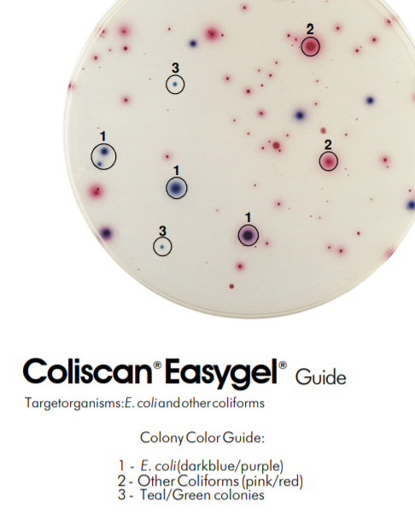

E. Coli Data Sheet

Name(s): __________________________________________________________
Date: ________________________ Group _________________
Volume of Sample Added: 2 ml
Petri Dish | Day/Time Incubation Started | Day/Time Incubation Ended | Purple Count | Purple and Pink Count
1 (unfiltered)
2 (unfiltered)
1 (after filtering)
2 (after filtering)

Volume of Sample Added: 5 ml
Petri Dish | Day/Time Incubation Started | Day/Time Incubation Ended | Purple Count | Purple and Pink Count
1 (unfiltered)
2 (unfiltered)
1 (after filtering)
2 (after filtering)

