BSF PVC Column Filter Construction

Safety Note: Personal protective equipment (PPE) should be worn during construction, such as safety glasses and hearing protection. Make sure that students have learned safe operating procedures before they use tools, such as saws and drills. Use the PVC primer and cement in a well-ventilated area and wear latex or nitrile gloves when handling glue.

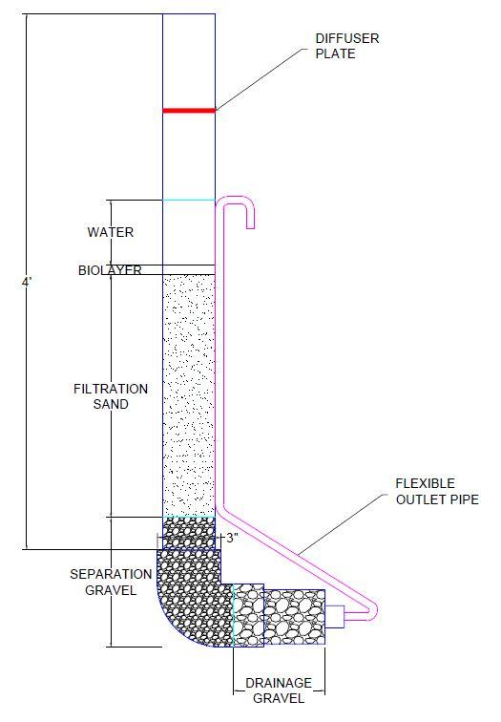
- Glue the 3” elbow onto one end of the 3’ piece of 3” PVC using the primer and PVC cement*
- Glue the 5” piece of 3” PVC into the other end of the elbow
- Glue the reducing fitting onto the 5” piece of 3” PVC
- Glue the bushing into the reducing fitting
- Put Teflon tape on the threads of the barbed fitting
- Screw the barbed fitting into the bushing, making sure the elbow points to the top of the column
- Push the tubing over the barbed fitting with the hose clamp around the tubing
- Tighten the hose clamp as much as possible with a screwdriver
- Tape the top of the tubing to the BSF column so that the water level is 1” above the sand layer
- Secure the BSF to the wooden stand with the large hose clamps.

* While wearing protective gloves, paint the purple PVC Primer on the two ends of PVC that you wish to glue together, making sure to cover it completely. Before the primer dries, paint the blue cement on the male end and quickly put it into the female end. Twist the fitting into place, then let dry for thirty minutes.

Filter Materials
- 3’ of 3” PVC
- 5” of 3” PVC
- 3” PVC 90˚ Hub × Hub elbow
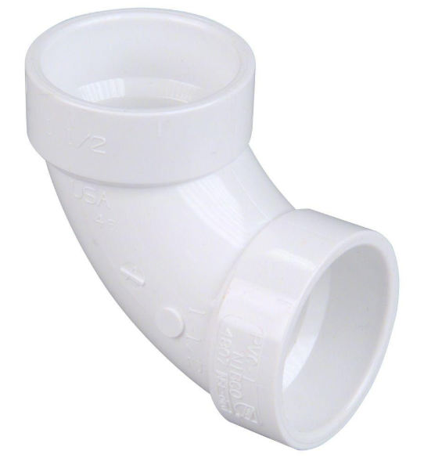
- 3” × 1 1/2” PVC Hub × Hub Reducing Coupling Fitting
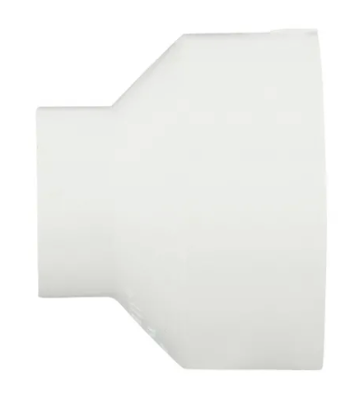
- 1 1/2” × 1/2” PVC Reducer Bushing
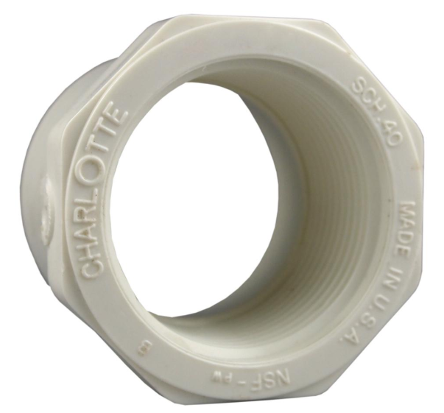

- 3/8” I.D. × 1/2” Barbed Elbow
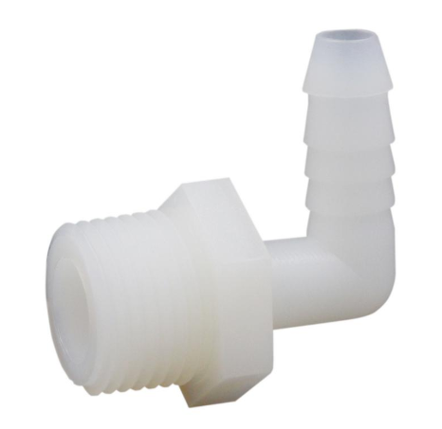

- 1/2” I.D. Flexible Tubing
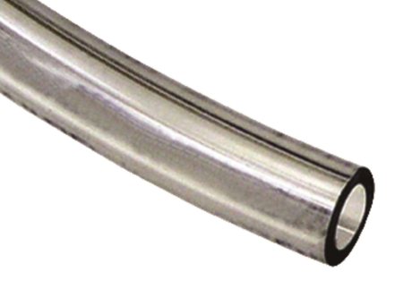
- 1/2” × 1 1/4” Hose Clamp
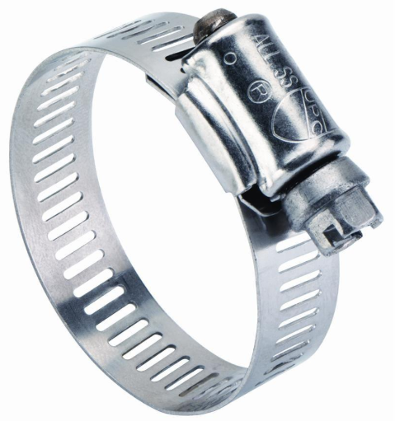
- Teflon Tape
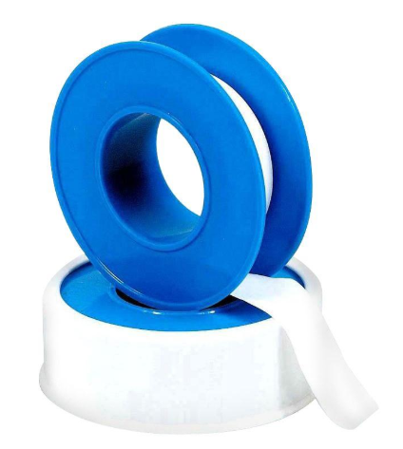

- PVC Primer and Cement
