BSF PVC Column Frame Construction

Safety Note: Personal protective equipment (PPE) should be worn during construction, such as safety glasses and hearing protection. Make sure that students have learned safe operating procedures before they use tools, such as saws and drills.

- Cut the pine lumber to the correct lengths.
- Assemble the frame using construction screws as shown in the diagram to the right.
- Attach the hose clamps to the 1x4s as shown using the construction screws. Note that you may need to drill holes in the clamps for the screws. Make sure that the opening of the clamps are to the front of the stand.

Frame Materials
2 4 ft. lengths of 1x4 pine lumber
2 3 ft. lengths of 2x4 pine lumber
2 2 ft. lengths of 2x4 pine lumber
Note: you can purchase the 1x4 as one 8ft. length and the 2x4 as one 10 ft. length and cut to size
8 3 in. - 5 in. stainless-steel hose clamps
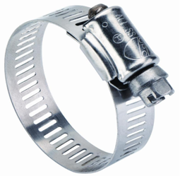

Construction screws, 2 in. length to connect 1x4s and 2x4s, 2 ½ in. length to connect 2x4s to 2x4s, and ¾ in. length to connect hose clamps to 1x4s
