**BIO**

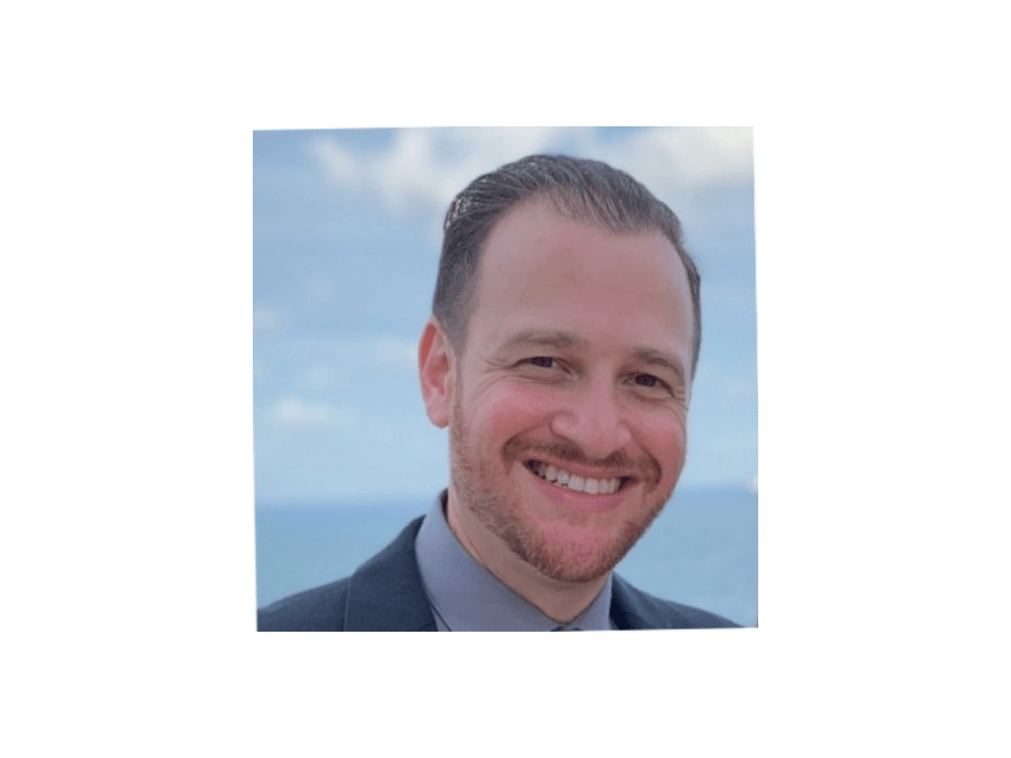

**Adam Rutstein**

Adam Rutstein has been in the Environmental, Social and Governance (ESG) space for nearly 15 years.  He is currently the Director of Global Corporate Responsibility at TD SYNNEX,  a leading global distributor and solutions aggregator for the IT ecosystem.  Adam leads their ESG program which includes the development of their Global Sustainability strategy.  He works with key business stakeholders to deliver on goals and initiatives that make a meaningful difference in the world.

Adam has a proven track record of helping businesses develop, implement and achieve their ESG goals. Prior to TD SYNNEX, Adam worked for Newell Brands, a worldwide manufacturer, marketer and distributor of more than 120 consumer and commercial products including  Rubbermaid, Mr. Coffee, Sunbeam, Oster and Sharpie.  At Newell, he developed a comprehensive corporate social responsibility program that is now the standard for all the brands in Newell’s portfolio and led the development of the company’s first Corporate Social Responsibility report.

Adam has participated and partnered with organizations such as the Business for Social Responsibility, The Sustainability Consortium, CDP, Treedom and the Arbor Day Foundation.

He received his Bachelor of Science degree from the University of Central Florida and his MBA from Lynn University.