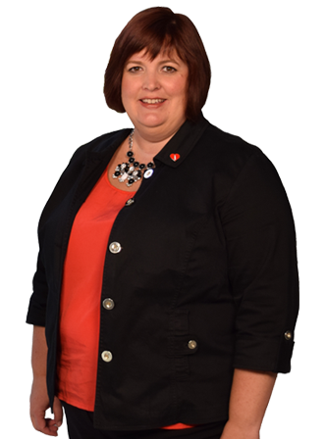
Ms. Erin Black Vice President, Sustainability, Risk Management, and Facilities
Coca-Cola Beverages Florida, LLC (Coke Florida)

Coke Florida is the 3rd largest privately held and the sixth-largest independent bottler of Coca-Cola products in the United States. Ms. Black leads the company’s strategy and execution of Risk Management and Sustainability with proven enterprise-wide strategy creation. Her role oversees a large risk portfolio that leverages her extensive risk management, process improvement, compliance and process modeling and analyst experience. Ms. Black formerly served as Coca-Cola Refreshments’ Vice President of Environmental, Health, Safety and Sustainability. Her professional experience also includes Kellogg Company, where she served as Senior Global Technical Director Environmental and Safety. She has also served as Director of Environmental, Health and Safety for Sara Lee, as well as Burns Philip, Inc.
Mrs. Black is an active board member and advocate who serves on the Board of Directors Executive Committee of Keep Florida Beautiful and will transition to Chair in July 2021 and on the Board of Directors for Florida Chamber Safety Council, The Florida Recycling Partnership, and Sustainable Florida. Ms. Black holds multiple degrees including an advanced degree from Drake University.

