Byron DeLear
Ygrene Energy Fund

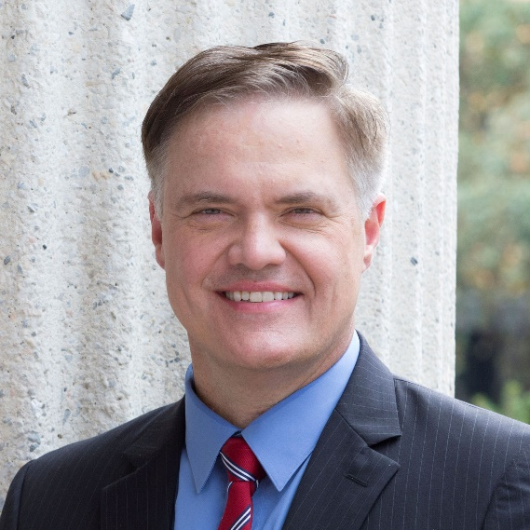
Byron DeLear is Managing Director and Central Regional Executive - Midwest for Ygrene Energy Fund. As such, he oversees Ygrene’s programs in Missouri, Ohio and the firm’s jurisdictional expansion in the Midwestern region of the United States.
Byron is an expert on sustainability policy and, as the founder and former CEO of Energy Equity Funding (EEF), one of the nation's pioneering Property Assessed Clean Energy (PACE) program administrators. EEF has designed, implemented, and administered PACE programs since 2010 and was acquired by Ygrene in 2017.
In 2009, Byron founded the Missouri Association of Accredited Energy Professionals (MAAEP) which was instrumental in helping organize contractors within Missouri’s clean-energy industry. In 2010, Byron helped build the coalition to pass Missouri PACE clean-energy legislation by testifying in legislative hearings and conducting educational sessions at the Capitol and statewide to various stakeholder groups.
He has been instrumental in the design and launch of PACE programs in Missouri, Ohio, Illinois, and several programs in Arkansas. Noteworthy achievements include Set the PACE St. Louis’s minority and women contractor equity and inclusion program. In 2017, Ygrene was awarded the Community Partner Award from MOKAN, the region’s leading minority contractors association.
Byron is an author, twice former U.S. House candidate, and serves on the boards of several non-governmental organizations that focus on economic, environmental, and social development. Recent committee and board work include serving on the Covid-19 Economic Rescue Team Working Group for St. Louis County, Missouri Energy Initiative, and Hawthorn Foundation. Byron has been a presenter on sustainability and PACE financing at the Atlantic Council in Washington DC, Midwest and Climate Policy Conferences (2010 and 2011), PACE Nation Summits (2016, 2017, 2019), University of South Florida Patel Global School of Sustainability (2019 and 2021) and is the recipient of the Energy Efficiency Champion Award from Renew Missouri.

He has been a featured presenter on PACE financing at the Atlantic Council in Washington DC, Midwest and Climate Policy Conferences (2010 and 2011), PACE Nation Summits (2016 and 2017), and is the recipient of the Energy Efficiency Champion Award from Renew Missouri.

