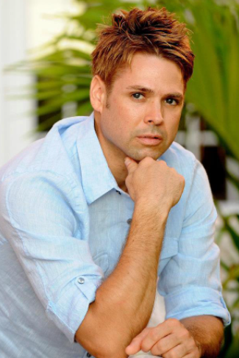

Donald L. Smith
Yara North America
Director, EHS & Sustainability

During the span of Don’s career, he has covered environmental & safety regulatory compliance, product quality & stewardship, sustainability & alternative energy as well as operations management – all while leading numerous key initiatives and large capital projects for Fortune 500 companies. At Yara, he currently leads the North American EHS & Sustainability Program for the world’s largest nitrogen fertilizer producer. In addition, he serves on the Board of Directors for Synagri Fertilizer of Canada and currently sits USF College Patel of Sustainability’s Industry Advisory Committee.

Don grew up in the Rocky Mountains of Wyoming - but now calls the sunny beaches of Florida’s west coast his home. He received his Bachelors of Science degree in Environmental Sciences at the University of Wyoming and later continued his education 15 years later by earning a Master’s of Business Administration degree (MBA) in Executive Management at the University of South Florida in Tampa.

In the community, Don participates in volunteer work for charitable organizations such as Habitat for Humanity, Big Brothers Big Sisters and Tampa Bay Watch.

