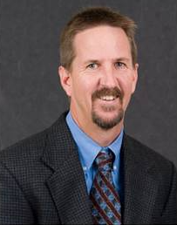
Thomas K. Frazer
Thomas K. Frazer is a Professor and Dean of the College of Marine Science at the University of South Florida. Prior to his arrival at USF, Dr. Frazer was Director of the School of Natural Resources and Environment at the University of Florida and served also as Chief Science Officer for the State of Florida. Dr. Frazer holds a Bachelor’s Degree in Fisheries Biology from Humboldt State University and a Master’s Degree in Fisheries and Aquatic Sciences from the University of Florida. He earned his Ph.D. in Biological Sciences from the University of California, Santa Barbara. His research addresses contemporary and emerging environmental issues, and is, by nature, interdisciplinary. His work involves collaborators from disparate disciplines, and it includes sampling and experiments conducted across a wide range of spatial and temporal scales. Dr. Frazer has received research funding from a broad suite of granting entities to address topics pertaining to water quantity and quality, nutrient dynamics, biogeochemical processes, fish population dynamics, food web interactions, and ecological restoration of degraded ecosystems. He has conducted field research in both freshwater and marine systems around the globe, and he is intimately familiar with a broad suite of environmental and natural resource issues (e.g., eutrophication of fresh, estuarine, and coastal waters; invasive species; and the ecological impacts of contemporary environmental change, including coral bleaching, ocean acidification, and sea level rise). Dr. Frazer has authored and/or co-authored more than 175 peer-reviewed publications, technical reports, and book chapters. Dr. Frazer currently serves as Chair of the Gulf of Mexico Fisheries Management Council. He is also a member of APLU’s Board on Oceans, Atmosphere and Climate, and he previously served as member of the US EPA’s Oil Spill Research Strategy Review Panel.

