BIO
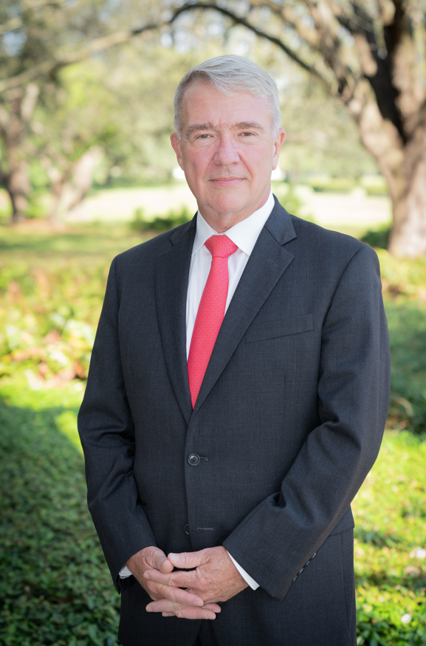
General (Ret) Kenneth F. “Frank” McKenzie, Jr.

General (Ret) Kenneth F. “Frank” McKenzie, Jr. is the Executive Director of the University of South Florida’s Global and National Security Institute and the Executive Director of the Florida Center for Cybersecurity, also known as Cyber Florida.
He is the former Commander, United States Central Command. A native of Birmingham, Alabama, upon graduation from The Citadel in 1979, General McKenzie was commissioned into the Marine Corps and trained as an infantry officer.
He has commanded at the platoon, company, battalion, Marine Expeditionary Unit (MEU), and component levels.
Upon promotion to Brigadier General in July 2007, he served on the Joint Staff as a Deputy Director of Operations within the National Military Command Center
In June 2014, he was promoted to Lieutenant General and assumed command of U.S. Marine Corps Forces, Central Command.
In July 2017, he was named the Director, Joint Staff. General McKenzie was promoted to the grade of General and assumed command of U.S. Central Command (CENTCOM) in March 2019. He relinquished command of CENTCOM and retired from the Marine Corps on 1 April 2022, completing over 42 years of service.
General McKenzie is an honors graduate of the Armor Officer Advanced Course, Marine Corps Command and Staff College, and the School of Advanced Warfighting. He was selected as a CMC Fellow in 1999, and served as a Senior Military Fellow within the Institute for National Strategic Studies at the National Defense University. He has a master’s degree in teaching with a concentration in history. He is currently the President of the Board of Directors of the Institute of Applied Engineering at the University of South Florida, a Distinguished Senior Fellow on National Security at the Middle East Institute, a Member of the International Advisory Committee of the National Council on U.S. Arab relations, and a Member of the National Security Advisory Council, U.S. Global Leadership Coalition.

