Greg Miller
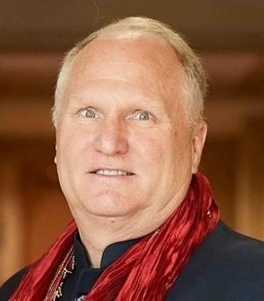
Gregory A. Miller, Ph.D.
Executive Director, Center for Responsible Travel (CREST)
Dr. Gregory Miller is a leader in responsible tourism, public-private partnerships, and a trained environmental scientist who believes in working globally, acting locally, and protecting our precious natural and cultural resources. Greg joined CREST as Executive Director in 2019,
bringing to the organization a global track record of high-impact results in sustainable travel and recreation, biodiversity conservation, and policy development. He is also a founder of the newly formed Future of Travel Coalition, as well as the Outdoor Alliance, National Wilderness Stewardship Alliance, and Parks in Peril program.
For more than 25 years, Dr. Miller distinguished himself as Vice President for the Andes/Southern Cone Region at The Nature Conservancy (which included global ecotourism programs), President of the American Hiking Society, President & CEO of NatureServe, and as Latin America and Caribbean environmental advisor for the U.S. Agency for International Development. As a global environmental consultant, Greg provided expertise and leadership on land and marine-based projects focused on biodiversity conservation, climate change, corporate social responsibility, and ecotourism.
A native of California, Greg is fluent in Spanish and English. He holds a Ph.D. in Ecology from the University of Connecticut, was awarded a Science, Engineering, and Diplomacy post-doctoral fellowship with the American Association for the Advancement of Science, and graduated from
the University of California, Santa Barbara with a B.A. in Botany. Dr. Miller is a responsible travel and environment expert cited by the New York Times, Washington Post, Time, Newsweek, CNN, Condé Nast Traveler, TravelPulse, Globe and Mail, Expedia, Kiplinger, Skift, AFAR, Travel and Leisure, O Magazine, and Architectural Digest. In addition to his executive experience, Greg worked for several years as a naturalist-guide in the Galápagos Islands, Andes and Amazon, served on the boards of The Ecotourism Society, Biodiversity Support Program, and Blue Ridge Center for Environmental Stewardship, and has held a lifelong commitment to environmental stewardship and exploring the outdoors responsibly.

