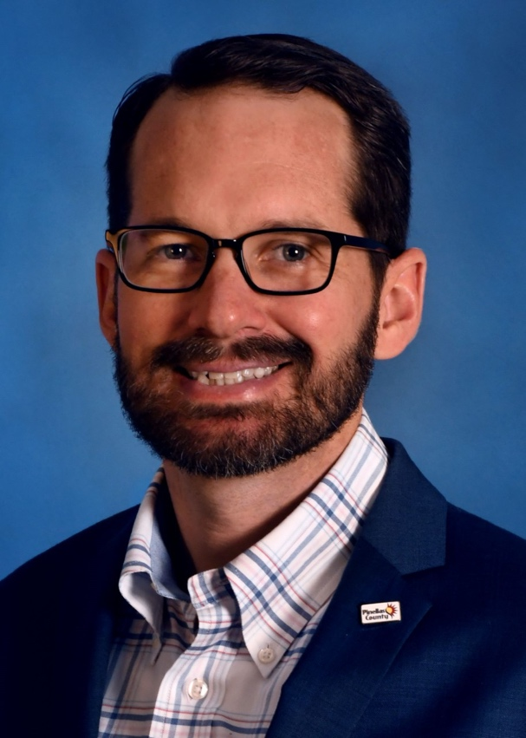

Henry (Hank) Hodde, M.S., CFM, ENV SP
Hank Hodde is the Sustainability and Resiliency Program Coordinator for Pinellas County, FL, where he oversees a new planning and program initiative aimed at reducing negative impacts to local communities and the environment, adapting to a changing climate, and promoting long-term sustainability and resiliency of the County’s resources and residents. He is a Certified Floodplain Manager, and ENVISION Specialist, with extensive experience in community resilience, coastal resource management, and climate change adaptation on the federal, state, and local levels. Prior to his current role, Hank served as the Planning and Policy Manager for Smart Home America, Resilience Outreach Specialist for Mississippi-Alabama Sea Grant Consortium, and Coastal Management Specialist for the National Oceanic and Atmospheric Administration (NOAA). He holds a Master of Science in Environmental Management from the University of Houston-Clear Lake and a Bachelor of Science in Residential Sciences from Florida State University. Following graduate school, he was a recipient of the 2013 NOAA Sea Grant Dean John A. Knauss Marine Policy Fellowship.

