Jared Meyers BIO
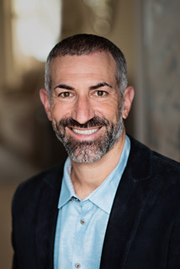
Jared Meyers is a values-driven professional dedicated to utilizing his time, resources and abilities to improve social, environmental and economic issues through Certified B Corporations and the Business for Good movement. Meyers is the owner of two successful Florida-based B Corps, Legacy Vacation Resorts (LVR) and Salt Palm Development (SPD), and also a Founding Director for Climate First Bank (i/o). With each of his companies, Meyers seeks to tackle social and environmental injustices and create measurable positive impact through policies, programs and investments back in to the communities where they are found with the hope of creating a thriving, purpose-driven economy. Always looking to the bigger picture for his impact goals, Meyers co-founded the For Good Movement, a 501(c)3 nonprofit that oversees Florida for Good and B Tourism. Florida for Good serves as a connector between B Corps, Conscious Capitalism, 1% For the Planet, like minded organizations/networks, governments/chambers, academia, and the local For Good ecosystems throughout the state. B Tourism serves a global network of Certified B Corporation travel and tourism companies as well as other conscious travel organizations taking collective action for the betterment of society and the health of our planet. The platform serves as a resource for the regenerative travel movement and to help travelers enjoy a vacation experience that understands interdependence and interconnectedness.

