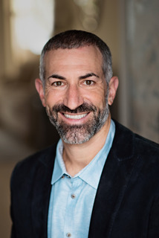

Jared Meyers is a hospitality veteran with more than 20 years in the industry. The University of Florida graduate is passionate about delivering a quality product through his company, Legacy Vacation Resorts, to help friends and families enjoy unforgettable vacations together. One of his other passions? Utilizing the power of his business as a force for good. Searching for a way to use his resources and abilities for positive change, Meyers learned about Certified B Corporations – companies that voluntarily meet the highest levels of social and environmental performance with transparency and accountability. Inspired by his findings, he immediately set out on a journey to transform his company into a Certified B Corp and also create a movement to help other hospitality and travel businesses to do the same. Always looking toward the bigger picture for his social and environmental impact goals, Meyers co-created the Florida for Good program. With its entrepreneurial spirit, Florida For Good is the connector between B Corps, Conscious Capitalism, 1% For The Planet, like minded organizations/networks, governments/chambers, academia, and the localized For Good ecosystems throughout the state.