Biography
Laura Stargel

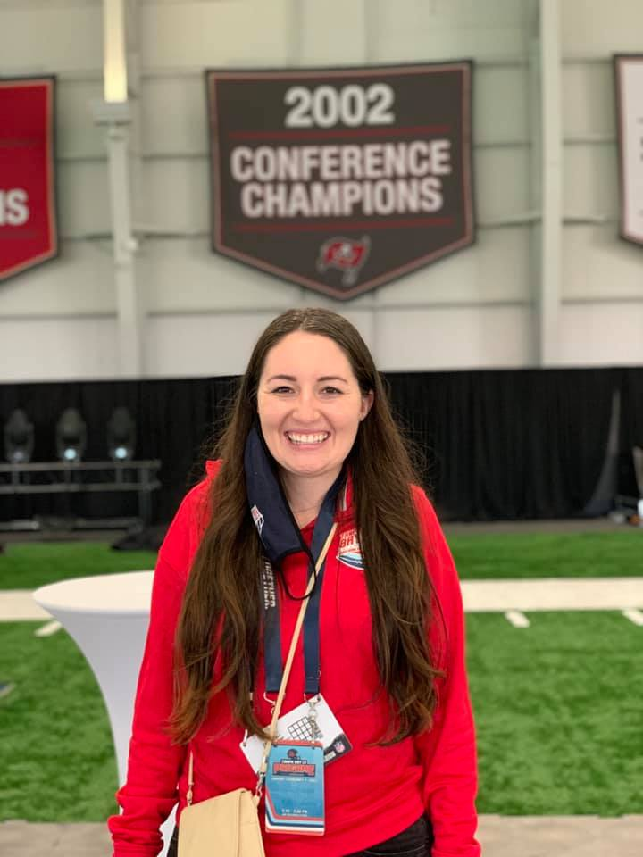

Laura Stargel is a 2020 graduate of the Patel College of Global Sustainability receiving her MA with a concentration in Sustainability Policy and graduate certificate in Sustainable Tourism. She currently is an ORISE Research Fellow at the US Environmental Protection Agency's Office of Research and Development in DC. Her current research utilizes participatory design and social science research methods to develop tools for innovation in equitable community resilience for local governments. Prior to her fellowship at the EPA, she served as the Sustainability Coordinator for the Tampa Bay Super Bowl LV Host Committee. Her work within sport ecology and equitable resilience has been recognized by Global Sports Week, being selected as a two-time Young Sports Maker representing the United States; Sport Ecology Group as a member of the Graduate Student Mentorship Initiative; and as a selected speaker to conferences, universities, and organizations including the University of Louisville, Florida Climate Week, and the Climate Champions podcast.

