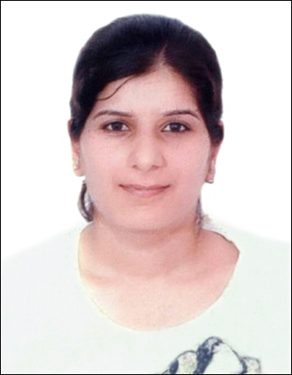

I am currently working with Dr. George Philippidis in the area of sustainable energy focusing on Algal biotechnology and Biomass conversion. My current research theme embraces integrated algal omics and engineering algae for enhanced lipid production. My research focuses on algal based biofuels, bioremediation, platform and chemicals and value-added products (such as nutraceuticals). I earned a Ph.D. in Biotechnology from Indian Institute of Technology Roorkee, India. I have a M.Tech and B.Tech Degree in Biotechnology. I was the receipt of prestigious Bioenergy-Award for Cutting Edge research fellowship funded by IUSSTF and Government of India. My professional goal is to develop algal based biorefinery for sustainable solutions pertaining to energy and nutrition demand and waste mitigation.

