BIO

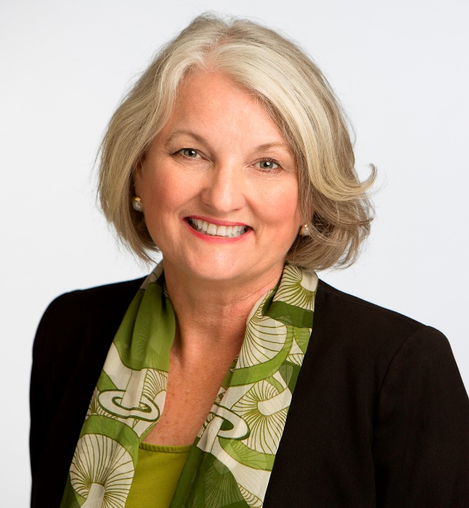

Pat Kemp

Patricia “Pat” Kemp was elected to the County Commission in 2016 and in 2020 representing Countywide District 6.

Commissioner Kemp has more than three decades of public service in Hillsborough County. She was chief aide to Congresswoman Kathy Castor when Castor served on the Hillsborough County Commission. Commissioner Kemp also served as aide to State Rep. Sara Romeo.

As an attorney, she worked both in private practice and for Bay Area Legal Services, providing civil legal services for low-income clients. As a journalist, she served as news director and a radio talk show host at WUSF and WMNF.

Over the years, Commissioner Kemp has volunteered for many community projects and organizations. She co-founded the Old Seminole Heights Neighborhood Association. She served in leadership roles for the Sierra Club of Tampa Bay and on the board of Tampa Crossroads, a nonprofit that provides counseling, treatment, housing and other services to veterans, the disabled, and others in need of assistance.

Commissioner Kemp has long been an advocate for improving transportation in the county and the region.

