KAYLA CASELLI
S U S T A I N A B I L I T Y P R O F E S S I O N A L

A B O U T

S K I L L S

AASHE STARS OP-6 & 7
Adobe Premiere Rush Asset-Based Community
Development Mapping Collaborative Nature Iterative Problem Solving
LeanPath Program Management Nested Sustainability Framework Novice Spanish Speaker Proactive Project Management ReCollect Program Management

P R O F E S S I O N A L A C T I V I T I E S

Grow Gardens Conference | 2021 Sustainability & Resiliency During the Pandemic Conference | 2021 Florida Food Policy Council | 2020 Future of Food Forum | 2020
Sustainable Livestock Seminar | 2019
Graduate student seeking to further hone the tools needed to create resilient solutions to sustain the world by the year 2050. I hope to draw on my systems- thinking foundation and experiences from seed(stock) to fork, as I further my knowledge of agriculture, food systems, solid waste, and circular economies.

W O R K E X P E R I E N C E

COOPERATIVE EDUCATION STUDENT INTERN
City of Tampa Department of Solid Waste | Aug 2021 - Current
Prepare and launch ReCollect application
Assist with communication campaigns, materials, and outreach Strategize growth and organization of backyard composting program Propose sustainable procurement policy

SUSTAINABILITY MANAGER
Gator Dining Services/Aramark | Nov 2018 - Jul 2020
Collaborated interdepartmentally to achieve campus-wide sustainability efforts Developed and branded local procurement program resulting in the increase of local vendor partnerships from 2 to 8
Reported impacts to the leadership team and university stakeholders Engaged students, faculty, and staff in sustainability initiatives Standardized employee waste minimization trainings

C O N T A C T

A: 3119 W De Leon ST
Tampa, FL 33609

P: 305-915-6190
E: kaylacb12@yahoo.com

S O C I A L

www.linkedin.com/in/kayla-caselli

E D U C A T I O N

MASTER OF SCIENCE, MAJOR IN GLOBAL SUSTAINABILITY
Food Sustainability & Security Concentration University of South Florida | 2020 - 2022

BACHELOR OF SCIENCE, MAJOR IN ANIMAL SCIENCES
University of Florida | 2015 - 2018

C E R T I F I C A T I O N S

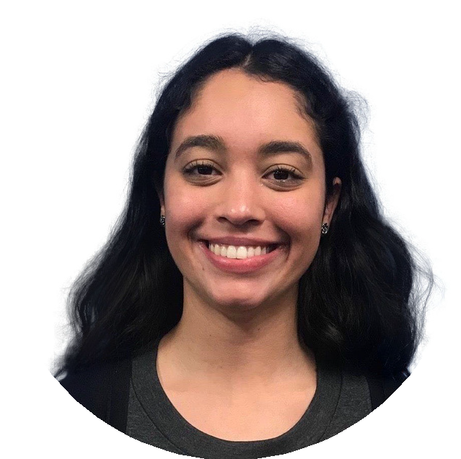

DIVERSITY, EQUITY, & INCLUSION IN THE WORKPLACE
University of South Florida | May 2021

CLIMATE & FOOD JUSTICE
The Cleo Institute | Aug 2020

SUSTAINABLE DEVELOPMENT MASTER CLASS
P4H | Jul 2020

GLOBAL LEADERSHIP & CHANGE
University of Florida | May 2018

