BIO
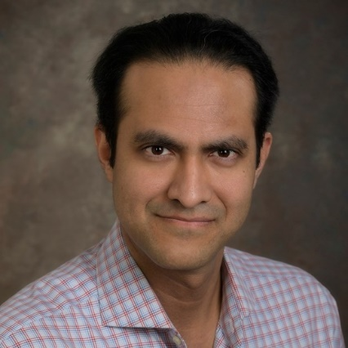
Saleem H. Ali

Saleem H. Ali holds the Blue and Gold Distinguished Professorship in Geography and Spatial Sciences at the University of Delaware (USA) and is Honorary Professor at the University of Queensland (Australia). Dr. Ali's laurels include being a National Geographic Explorer (having travelled for research to over 150 countries); being chosen as a Young Global Leader by the World Economic Forum and serving on the seven-member science panel of the Global Environment Facility (the world's largest multilateral trust fund for the environment held in trusteeship by the World Bank). His earlier books include “Earthly Order: How Natural Laws Define Human Life” (Oxford Univ. Press); and “Treasures of the Earth: Need Greed and a Sustainable Future” (Yale University Press) which was hailed by Nobel laureate Muhammad Yunus as providing "welcome linkage between environmental behavior and poverty alleviation." Professor Ali was profiled in Forbes as "The Alchemist" and Bookseller called his earlier work "a pioneering exploration of human wants and needs and the natural resources we consume." He is a Fellow of the Royal Society of Art sand the Royal Geographical Society in the United Kingdom and also serves on the boards of Adventure Scientists and Mediators Beyond Borders International.

