Biography
Sonia Joshi

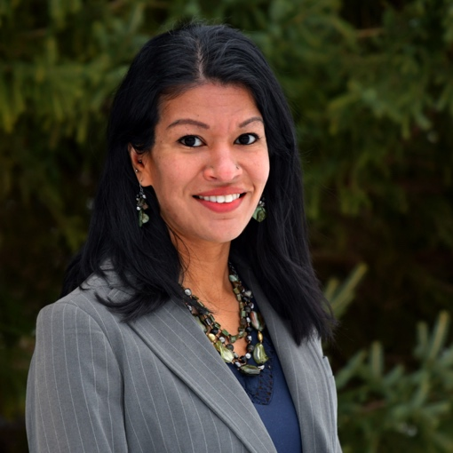

Sonia Joshi (she/her) is Associate Director of U.S. Programs at Institute for Sustainable Communities (ISC). Sonia works with leaders of color, community organizations, and local and regional governments to prioritize and infuse racial equity into climate resilience. She holds a Bachelor's degree in Environmental Science from Lake Superior State University and a Master's degree in Human Dimensions of Fisheries and Wildlife, with a specialization in Gender, Justice and Environmental Change from Michigan State University. Before joining ISC, Sonia spent four years as the inaugural Diversity, Equity, and Inclusion (DEI) Program Manager for the School for Environment and Sustainability (SEAS) at the University of Michigan, facilitating dialogues across social identities, privilege, race, and power. Prior to her time at SEAS, Sonia spent eleven years as Program Manager and Outreach Coordinator in a joint position between the Great Lakes Sea Grant Network and the NOAA Great Lakes Environmental Research Laboratory. There, Sonia managed the multi-state NOAA Center of Excellence for Great Lakes and Human Health.

