**BIO**

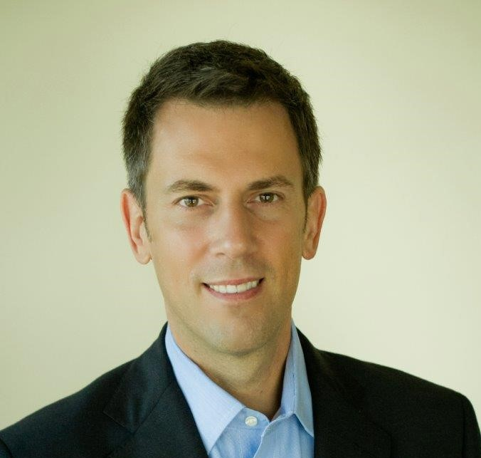

**T.J. King**

T.J. King has been a financial advisor since 1991 and a Certified Financial Planner® since 2004. He has an MBA with a concentration in finance and international business from the University of South Florida. He is an Accredited Investment Fiduciary® and is currently enrolled in the Chartered Advisor in Philanthropy® program. T.J. and his team have utilized sustainable investing strategies for over two decades. His interest in sustainable investing is a natural extension of his activism in social justice and environmental causes.

He and his team are committed to developing the connections between sustainable investing and philanthropy to maximize their clients’ impact on the issues that matter most to them. T.J. serves on both Raymond James’ Sustainable Investment Advisory Committee and Sustainability Committee. In regards to my talk, I will open with the evolution of sustainable investing from the early days of socially responsible investing to the recent focus on ESG and how I think this evolution will continue with a focus on impact.

I will relate how we consider investors’ specific values in selecting specific investments for their portfolio. I can also provide some thoughts on how publicly traded corporations are approaching ESG reporting and encompassing all stakeholders in their sustainability objectives.