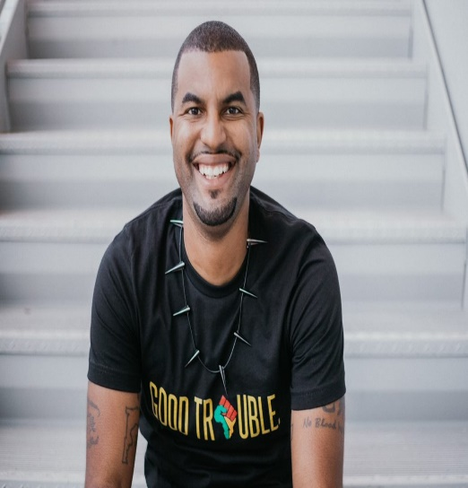

A native of Baltimore Maryland, Ryan Watson is an award-winning videographer and filmmaker, working in the Tampa Bay area since 2006. His areas of expertise include documentary production, cinematography, videography and drone videography. He has been a post-secondary educator since 2012 teaching various aspects of TV and film production in Tampa, Fl. Currently, Ryan is a Full-Time Instructor at the University of South Florida's Zimmerman School of Advertising and Mass Communications.

Ryan earned a Bachelor's degree in Mass Communications from the University of South Florida in 2006. He obtained his Master of Fine Arts degree in Digital Cinematography from National University in Los Angeles in 2015. Professor Watson is an FAA certified UAS pilot and in the spring semester of 2018 he launched USF’s first drone videography course. In 2021 he launched the first Virtual Production course at USF

His professional experience began at WTTA-38 as a creative services producer before working for the Seminole Tribe of Florida as a Video Production Coordinator in 2009. During this time, he produced hundreds of segments documenting the activities of the Seminole Tribe of Florida as well as other Native American tribes around the country. Ryan also served as the primary Video Producer for the Seminole Hard Rock Tampa.
In 2015 his film, Florida State’s 1st Seminole, won the Audience Choice Award at the Gasparilla International Film Festival graduate student showcase. He has since directed two award winning films; The Ivory League: Confessions of a Black Faculty (2021) Best Florida Film 2021 Sunscreen Film Festival & Paper Line (2022) Best Narrative Feature 2022 Baltimore International Black Film Festival.
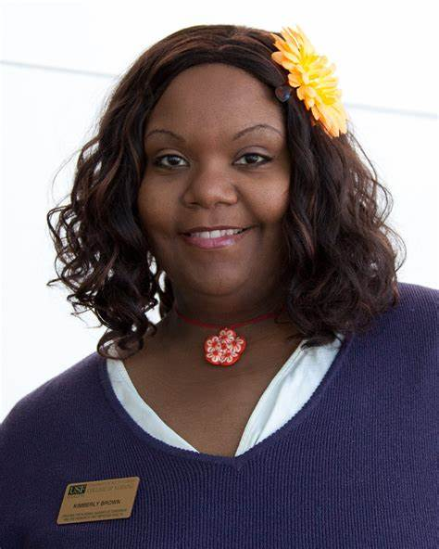

Kimberly was born in Titusville, Florida; home of the famous space shuttle launches. Reaching for her own stars, Kimberly moved to Tampa and joined the University of South Florida family (USF) as both a student and an employee. Over the years, Kimberly has completed coursework in Substance Abuse Counseling, in Business Administration, legal Assisting, and she earned a Bachelors of Science Degree in Social Science.
Kimberly genuinely cares for her alma mater, and is actively involved in workgroups for student success. She also serves as an Advisor for multiple student organizations, including the student chapter of the National Association for the Advancement of Colored People (NAACP). She holds memberships with the Administrative Advisory Council (AAC), the Black Faculty and Staff Association (BFSA), and the USF Presidential Advisory Committee on Black Affairs (COBA). Kimberly currently serves as the legal liaison between the USF College of Nursing and their multiple clinical partners, managing over 1200 student educational contracts.
Her interests in Diversity, Equality and Community, support her excitement for her pursuits in organizations such as the International Association of Administrative Professionals (IAAP), the National Association of Professional Women (NAPW), the Tampa Organization of Black Affairs (TOBA), the USF College of Nursing Diversity Committee, and the City of Tampa Mayor’s African American Advisory Council (MAAAC). While showing extraordinary dedication to community service, Kimberly manage events throughout Florida.
With her passion for quality work, Kimberly has received several awards over the years, including recognition as “Outstanding Staff”, “Staff of the Month”, and recognition from Black Girls Rock, USF, among others. In her spare time, Kimberly is either engaging in trainings or seminars to stay on trend, and as a respected local wedding or event planner, she is working to perfect her Spanish-speaking pronunciation.
Kimberly balances work, committee involvement, and foster-child placements, all while maintaining a colorful outlook on life. She is energetic, motivated, and genuinely passionate about each endeavor.
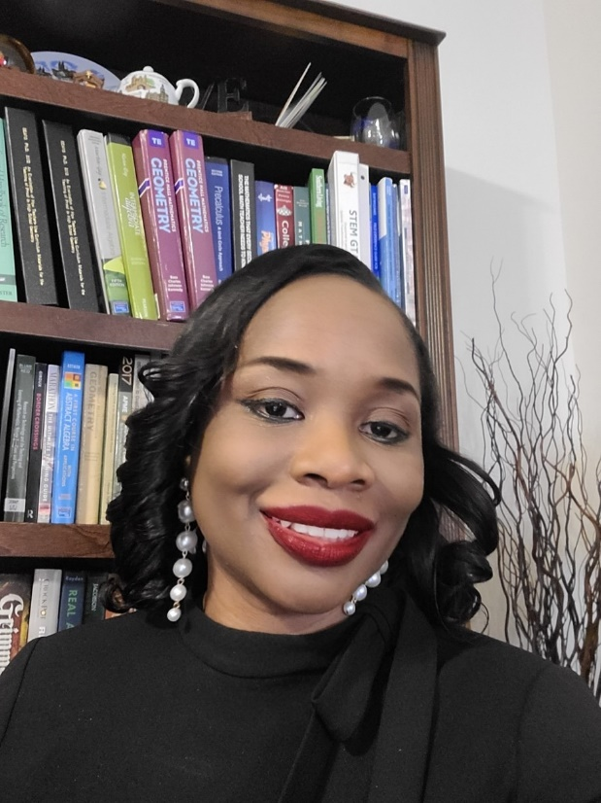

Dr. Sears is an associate professor for mathematics education, associate director for Coalition for Science Literacy with a focus on inclusive excellence, and lead faculty facilitator for the inclusive and equitable pedagogy program at the University of South Florida. Her research focuses on curriculum issues and systemic changes in K-20, the development of reasoning and proof skills, clinical experiences in secondary mathematics, and the integration of technology in mathematics teaching and learning. She has presented nationally and internationally and has published in leading mathematics education journals. She also coordinates developmental mathematics courses and the undergraduate and master's degree programs in mathematics education.

Dr. Sears is actively engaged in scholarly activities. She was the principal investigator for the
NSF-IUSE funded collaborative grant (#1726362) entitled "Attaining Excellence in Secondary Mathematics Clinical Experiences with a Lens on Equity" and is the co-principal investigator for the NSF-funded (#2142714) “Challenging Anti-Black Racism in Civil and Environmental Engineering Curriculum”. Dr. Sears is key personnel for the NSF-funded grant (#1525574) Systemic Transformation of Education through Evidence-Based Reforms (STEER), and the CyberFlorida grant entitled “The modernization of Digital Information Technology”.

In addition to her research activities, Dr. Sears provides extensive service to the profession and to her local environment. Notably, Dr. Sears is the co-chair of the Network of STEM Education Centers (NSEC) Annual Meeting, and the Accelerating Systemic Change Network (ASCN) in STEM Higher Education Working group for Diversity, Equity and Inclusion. She is also a University of South Florida representative for the Bay View Alliance. Moreover, Dr. Sears is the associate editor for the NCTM journal (Mathematics Teacher: Learning and Teaching PreK-12 (MTLT)) for the high school grade band, and the editor for the AAAS-ARISE Blog (https://aaas-arise.org/whats-new/blog/ ). Dr. Sears is also the Florida Department of Education – State Course Numbering System (SCNS) Discipline Coordinator in the field of Mathematics Education and STEM Education. Additionally, Dr. Sears is a board member for the Ronald McDonald House Charities of Tampa Bay and the Bahamas’ PACE Foundation.

At the University of South Florida, Dr. Sears is a member of the Anchin Center STEM Professional Development Leadership Team and serves on NSF funded STEER-Transformation Implementation Leadership Team (TILT). Dr. Sears serves on the university sabbatical committee, and as the constitution committee chair for the Faculty Policy Council. She is also the chair of the university-wide diversity equity and inclusion initiative entitled the Enlightenment Series (https://www.usf.edu/president/anti-racism/resources/enlightenment-series.aspx ), and is a member of the university’s IAspire Implementation Team, and the NSF funded “All ABOARD” – A Bull’s Eye for JEDI initiative.

Fellowships
November 2021 Association of American Advancement of Science (AAAS) Fellow 2021 AAAS Fellow https://www.aaas.org/fellows

June 2020 NSF-funded Aspire Alliance’s Institutional Change Network (IChange) IAspire Leadership Academy!
Second cohort fellow.

2008-2012 Center for the Study of Mathematics Curriculum (CSMC) Fellowship Award, which provided a four-year graduate assistantship with tuition waiver at the University of Missouri.

2004-2006 Organization of American States Fellowship Award, which paid for tuition, travel and living expenses while I attended Indiana University

Awards
August 5, 2022 Kappa Delta Pi – International Honor Society
2022 Chapter Leader Award Recipient for Regional Chapter Counselor

May 4, 2022 University of South Florida – College of Education
Excellence in Undergraduate Education Award

April 14, 2022 University of South Florida -Office of Multicultural Affairs
I Heart Diversity Award Recipient

April 12, 2022 University of South Florida - Office of Diversity, Equity and Inclusion
Inclusive Excellence Impact Award Recipient

March 2022 University of South Florida
Outstanding Faculty Award Recipient

October 2021 Association for Women in Mathematics Award (Nominated but not selected)
May 12, 2021 Black Faculty and Staff Association (BFSA) – Connections for Life- Mentorship Program – Paper Plate Award.

December 2019 National Council of Teachers of Mathematics (NCTM) - National Science Foundation (NSF) travel grant award for the14th International Congress on Mathematical Education (ICME-14) in Beijing China (July 11-19, 2020). This award provides $2,750 towards the cost of or registration, airfare, lodging, and meals

April 11, 2018 USF chapter of the National Council of Negro Women – Catherine Johnson STEM Award

February 18, 2017 Vex Robotics Competition – Volunteer of the Year Award for 2016-2017

October 22, 2016 Florida Association of Mathematics Teacher Educators (FAMTE)- Mathematics Teacher Educator of the Year Award 2016

March 18, 2015 University of South Florida's Chapter of the National Council of Negro Women -Black Girls Rock Honoree

March 2012 12th International Congress on Mathematical Education (ICME-12) Travel Grant Award, which waived the conference registration fee and provided $400.00 for travel reimbursement.

2)Role at USF
2021- Present Associate Director with a focus on Inclusive Excellence
Coalition for Science Literacy
College of Arts and Science, University of South Florida

2021 -Present Lead Faculty Facilitator
University of South Florida Inclusive and Equitable Pedagogy Program ((https://www.usf.edu/innovative-education/citl/inclusive-equitable-experience.aspx )

2018- Present Associate Professor
Secondary Mathematics
College of Education, University of South Florida
2018- Present Undergraduate B.S. and B.A. Grades 6-12 Program Coordinator and Mathematics Education M.A.T and M.Ed Program Coordinator
Secondary Mathematics
College of Education, University of South Florida

2013- Present Coordinator for Developmental Mathematics Courses
College of Education and College of Arts and Science, University of South Florida

2012-2018 Assistant Professor
Secondary Mathematics
College of Education, University of South Florida

