Status of Men Presidential Advisory Committee
Annual Report AY 2020-2021

Overview
The Status of Men Presidential Advisory Committee is charged with investigating, assessing, and recommending actions to increase the rate of degree progression and timely degree attainment among male undergraduates at the University of South Florida. Reflecting national and international trends, the gender achievement gap at USF is the largest equity gap that we have as an institution, eclipsing graduation rate gaps by race/ethnicity, Pell status, and first-generation status. It is persistent and evident across all demographic groups, colleges, and campuses.
Most impressive, the 51% 4-year graduation rate for 2016 FTIC men is the first time we have ever topped the 50% threshold (see tables below). This is an impressive 2.7% increase over the previous year. Because of the improved performance of men, the 4-year graduation gap by gender declined to 16%. This is a substantial improvement, as the average over the four prior years was 18.1% This gap narrows at the 6-year rate, which for the 2014 FTIC cohort was 10.2%. Another positive sign is that in recent years men have persisted at roughly the same first-year retention rate as women (90.8% for men versus 91.9% for women in the 2019 FTIC cohort).
Improving male success rates is a wicked problem involving a host of factors: academics, wellness, social, cultural, biological, and more. As such, it will take a coordinated, strategic, and long-term approach across all units to substantively improve the overall performance of our male students. There is no single silver bullet remedy to improving male degree progression, but there are numerous solutions to be found in our practices and policies. The Status of Men Presidential Advisory Committee is devoted to grappling with the data about our male students, identifying opportunities, and devising solutions to continue to support male students and narrow the gender equity gap in degree attainment.
USF Degree Progression Data by Gender
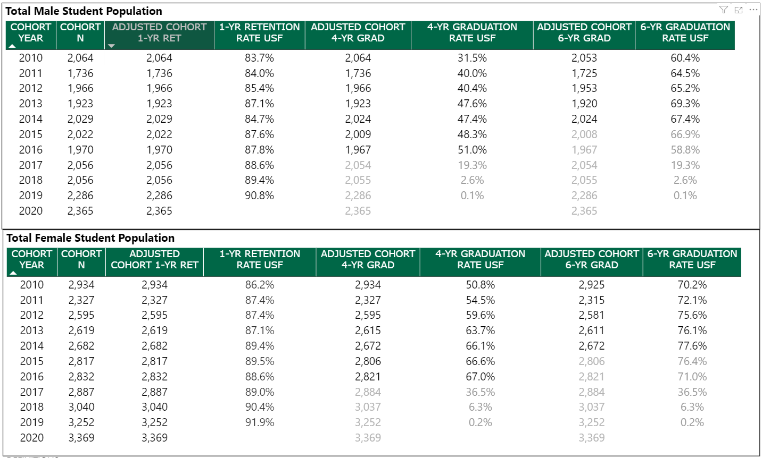
Male Success Initiatives in 2020-2021
In close coordination with Student Success and Diversity, Inclusion, and Equal Opportunity, the Status of Men Committee has initiated or contributed to the following initiatives, programs, and activities:
- Continued collaboration with partner universities as part of the APLU “Powered by Publics” initiative to promote degree attainment. USF is part of a cluster of 9 universities who have identified male student success as one of our two focus areas for collaboration over the next five years.
- Continued to run a Male Student Speaker Series to invite colleagues who have moved the needle on male collegiate achievement to USF to share best practices. Four universities joined us for remote events during this year.
- Developed an inventory of prospective male success programs and practices across the USF system with the potential to improve male success.
- Charged a Male Success Data Subcommittee with exploring the abundant data sets available at USF and identifying gaps/opportunities to improve outcomes. Key data sets include the National Collegiate Health Assessment, Beginning College Survey of Student Engagement, National Survey of Student Engagement, Graduating Senior Survey, National Student Clearinghouse.
- Charged a Male Peer Mentoring Subcommittee with developing a peer-to-peer mentoring pilot program aimed at male students starting in Fall 2021.
- Contributed to the Male Student Success Persistence Subcommittee that reviews data on male student progression and assists in getting students the assistance they need to meet their academic goals and stay on target for graduation.
- Developed a draft Male Student Success Dashboard of academic indicators and non-academic factors to help pinpoint opportunity areas for action.
- Created a dashboard for Tampa Campus Recreation that shows correlations between academic success and campus recreation participation. This is a Strategic Initiatives pilot that we hope to replicate with other units within Student Success to give them actionable views of their data.
- Conducted focus groups with male students to identify how they view the experience of being men at USF and how they have overcome DFW challenges.
Status of Men Committee Objectives for 2021-2022
- Continue to raise awareness across USF and among all stakeholders about the male achievement gap and the need to collaborate to reduce that gap.
- Gain buy-in from all units so that they take shared responsibility for moving the needle to raise degree completion rates among males.
- Develop a university-wide male success strategic plan as part of the Strategic Renewal plan. This includes identifying target retention and graduation rates at AAU public universities.
- Engage male students through focus groups and other mechanisms to deepen our understanding of the challenges they face.
- Assess ways we can leverage students and student organizations to raise awareness and develop solutions to the male progression challenge.
- Develop and run a male peer mentoring pilot program during the 2021-22 academic year with the goal of identifying practices that can be scaled and/or leveraged to promote male student success.
- Continued and sustained engagement with data sets with the goal of identifying specific changes in practice, policy, curriculum, or student life that can be forwarded as Status of Men Committee recommendations to relevant units across all three campuses.
- Build and launch a Male Student Success website
- Identify opportunities to change or enhance the broad structuring parameters in ways that assist students in progressing toward their degrees, cf. general education enhancement, Finish in Four, curricular analytics, advising practice, et cetera.

Status of Men Committee Recommendations to Leadership
- Develop accountability measures for male achievement across all units to build commitment and encourage broad action from within all academic colleges, student success offices, and other support units. Tie funding to performance.
- Continued messaging from senior university leadership about the male success challenge and the institutional commitment to reducing the equity degree achievement gap by gender.

Current Membership

Cummings, William, Chair | Associate Vice President & Professor | Student Success
Gentilini, Al | Director | Campus Recreation (St. Petersburg)
Gambrell, Darren | Coordinator | Student Services (Sarasota-Manatee)
Garcia, Valeria | Associate Vice President | Office of Decision Support
Goldsmith, Carmen | Assistant Director | Strategic Initiatives, Student Success
Isaacs, Dwayne | Director | Student Life (St. Petersburg)
Krein, Dustin | Program Planner | Office of Community Engagement & Partnerships (Tampa)
Marks, Chris | Associate Director | Recreation and Wellness (Tampa)
McNeish, Roxann | Research Assistant Professor | Child and Family Studies (Tampa)
Miller, Byron | Associate Professor | Sociology (St. Petersburg)
Miller, Tom | Special Advisor & Associate Professor | Student Success
Severy, Michael | Director | Center for Leadership and Civic Engagement (Tampa)
Strader, Scott | Director | Counseling Center (Tampa)
Thompson, Travis | Senior Product Owner | Information Technology
Vandello, Joseph | Professor | Psychology (Tampa)

