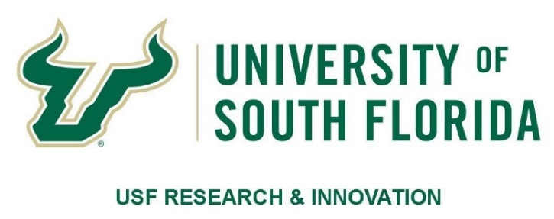

CALL FOR NOMINATIONS & NOMINATION FORM

Excellence in Innovation Awards

For the period January 2018 through June 2019 (18 months)

Deadline to submit applications:
Extended to 11:59 PM, November 8, 2019

Award Description:
- The Excellence in Innovation Award recognizes USF faculty for exceptional achievement, during the time period specified, in translational research and/or innovation and its transfer to practice, industrial partnerships, and or commercialization
- More than one award may be given
- Each winner will receive $2,000, presented at the USF Excellence in Innovation Awards luncheon, to be held on January 27, 2020
- All nominees whose application packets are received by the submission deadline and verified as complete will receive a Certificate of Recognition

Eligibility:
- Applicant/Nominee/Recipient must be a currently employed USF faculty member from any USF System institution and must have been employed by USF for the entire award period of January 1, 2018, through June 30, 2019.
- Achievement(s) submitted for the award application must have been accomplished or formally recognized between January 1, 2018, through June 30, 2019. Documentation must be provided. See Application Process below.
- Nominations may be made by the faculty applicant themselves or by a colleague on their behalf. (NOTE: Nominators and authors of Letters of Support are not eligible to apply for this award in the same award period in which they nominate/support a colleague)
- Letters of support required from nominee’s Dean or Chair as part of the nomination packet

Recognized Innovation Achievements Must Occur Within the Time Period of January 1, 2018, through June 30, 2019, and May Include, but are Not
Limited To:
- Development of new intellectual property (e.g., issued patent, patent application)
- Entrepreneurial achievement(s) (e.g., a USF-based start-up company, development of a license agreement, or development of a working relationship with an established company)
- Transition of a pre-clinical discovery into the clinic
- Commercialization of a USF-discovered product
- Funding obtained through federal programs, such as STIR or SBIR grants, with a grant award
- Significant publication(s) in technology (e.g., Science, Proceedings of IEEE, Nature, Biotechnology), published or accepted for publication

Review Criteria Within the Time Period of January 1, 2018, through June 30, 2019, May Include, But Are Not Limited To:
- Number of recognized achievement(s)
- Prestige of the achievement(s)
- Uniqueness or significance of the innovation or achievement(s)
- Type and amount of external funding awarded to USF, as a result of the stated achievement(s)

Application Process:
Each application packet must include all of the following:
- Nomination form – including a 150-word maximum description of the applicant’s innovation achievement(s) focused only within the time period of January 1, 2018, through
June 30, 2019
- Documentation of all the stated achievement(s) described in the application, such as a Patent Number, copy of a license agreement, copy of a published article or letter from a publisher accepting an article/book for publication, etc.
- The applicant’s CV
- A one-page letter of support from a Dean, Chairperson, or Center/Institute Director describing the achievement(s) and discussing the significance of the contribution made by the applicant/nominee

Award Process:
- The deadline to submit applications has been extended to:
11:59 PM, Friday, November 8, 2019
- Submit the entire Application Packet as a single PDF file to: judidorn@usf.edu
- Applications will be reviewed by the Innovation Award Committee, composed of members of the USF Chapter of the National Academy of Inventors. The Committee’s recommendations will be provided to the Senior Vice President for Research, Innovation & Knowledge Enterprise for use in the selection process.

Contact: Judi Dorn, USF Research & Innovation at 813-974-5122 or judidorn@usf.edu

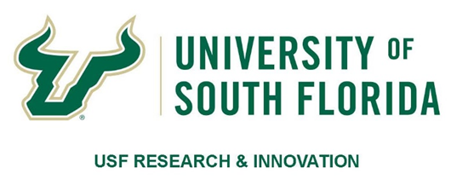
NOMINATION FORM

Excellence in Innovation Award

ALL achievements must have occurred within January 1, 2018, through June 30, 2019 (18 months)

Name of Nominee/Applicant:
Title:
Department:
College:
Campus Address:
E-Mail: | Phone:

Nominator’s Name (if applicable):
Nominator’s Title:
Nominator’s Department:
Nominator’s College:
Nominator’s Campus Address:
Nominator’s E-Mail: | Nominator’s Phone:

Description of Innovation Achievement(s):

In the text box below, provide a 150-word maximum description of the applicant’s innovation achievement(s) within the time period of January 1, 2018, through June 30, 2019.

Documentation of Innovation Achievement(s)
Provide documentation for all the stated achievement(s) described above, such as a Patent Number, copy of a license agreement, copy of a published article or letter from a publisher accepting an article/book for publication, etc.

Attach all the listed documentation to this Nomination Form.
List/Describe the provided documentation in the text box below:

Letter of Support
Include a (scanned) Letter of Support from a Dean, Chairperson, or Center/Institute Director. This letter must:
- Be printed on letterhead
- Be signed with an original (not digital) signature
- Letter is limited to one page (8 ½” x 11”)
- Must describe the applicant’s innovation achievement(s) and discuss the significance of the achievement(s) made by the nominee/applicant during the time period of January 1, 2018, through June 30, 2019

Completed Application Packet
- Save the Completed Application Packet to include the nominee’s name in the name of the file, e.g., “Doe, John - 2019 Excellence in Innovation Application”
- The completed application packet must include all of the following:
- Completed Nomination Form
- Documentation of all the stated achievement(s) described in the application
- Letter of support from a Dean, Chairperson, or Center/Institute Director
- Applicant’s CV

The deadline to submit applications has been extended to: 11:59 PM, Friday, November 8, 2019. Submit the entire Application Packet as one PDF file to: judidorn@usf.edu

CONTACT: Judi Dorn, USF Research & Innovation, 813-974-5122 or judidorn@usf.edu.

