
The Research Administration Improvement Network, TRAIN®
Business Process:
USF Internal Form

Overview or Process Summary: Prior to submitting a proposal, Principal Investigators must route the proposal for signatory approval by their Chair, Dean/Director, and the Division of Sponsored Research.
The Internal Form is the mechanism to officially establish approval to seek funding. This fully signed form is required prior to the establishment of the project within the Division of Sponsored Research.
Business Process
- Faculty and/or administrative staff access the Internal Form developed by the Division of Sponsored Research.
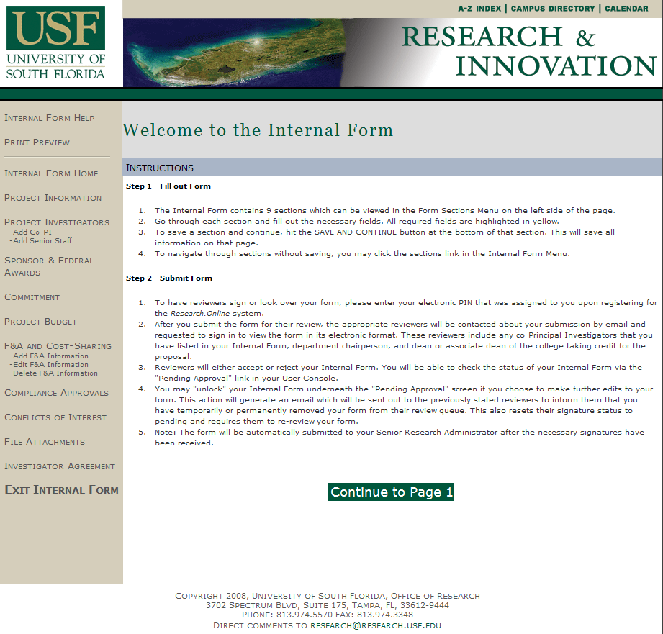
- You will need to register prior to using the Internal Form. To register, you will need to enter your College, Department, Name, GEMS ID (Employee ID) with leading zeroes, and Contact Information. You will also need to know your affiliation or user level: Undergraduate, Graduate, Faculty, Staff, CRAN or other. If you are a Department Research Administrator who will be starting or reviewing Internal Forms for faculty, check the box labeled “College Research Admin Network Access”, also known as CRAN. Chairs, Deans and/or delegates check the box labeled “Administrator’s Access.” Otherwise the boxes should be left blank. Select a Username and Password then click “Register.” Your PIN number will be emailed to you.
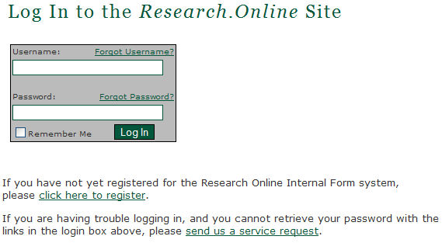
- To input a new Internal Form, faculty and/or administrative staff should select the option of “New Internal Form.”
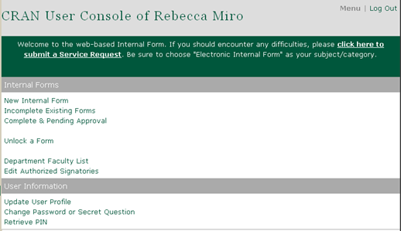

- The Instructions page provides basic information on how to fill out and submit the form. To begin, click “Continue to Page 1.”
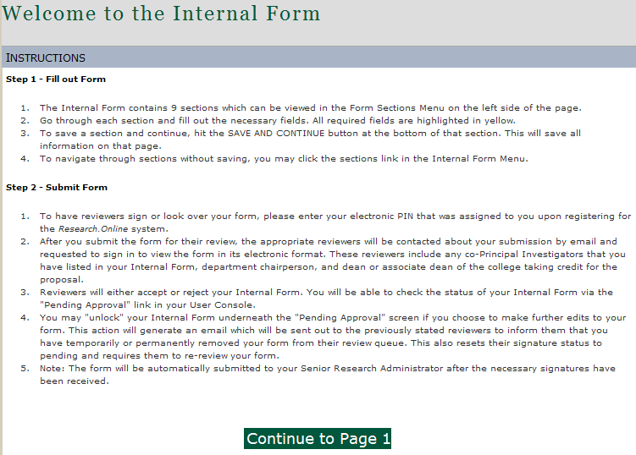

- Enter Project Information:
  - Indicate whether or not the proposal is in response to American Recovery and Reinvestment Act (ARRA) funding announcement.
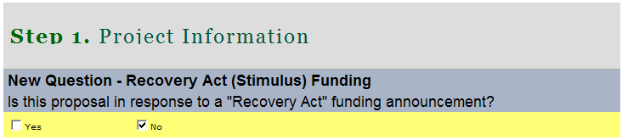
  - Select the Project Type: Competitive Renewal, Continuation, New Proposal, Pharmaceutical Contract, or Supplemental Request. Provide the FAST Project ID (Account Number), if continuation; Date Proposal Submitted to Sponsor (not applicable for new proposals), and Previous Proposal number (if any) in the boxes indicated.
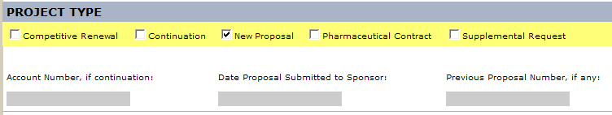
  - Enter the Project Title (must match title used to obtain IRB approval, if applicable); Keywords that best describe the project; and a layman’s description of the project.
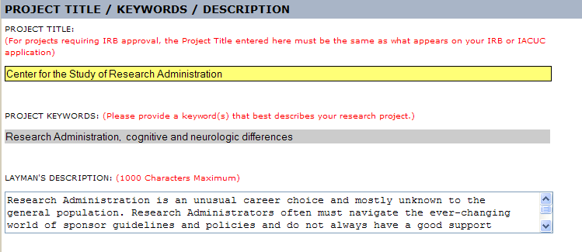
  - Enter the Project Type: Research, Training, or Other. If Other, please specify.

  - If this research was given a Department of Defense research classification, enter the type given: Classified, Unclassified, Unclassified Sensitive, Other. If not applicable, skip this section.
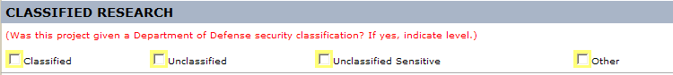
  - If this research is community-based, select yes. Otherwise, select no. To determine if a project is community-based, ask whether the project involves partnerships and/or beneficiaries at the local or regional level or if it has immediate or short term possibilities to help solve problems that affect the citizens of this locality or region. If the answer to either is yes, this is a community-based project.
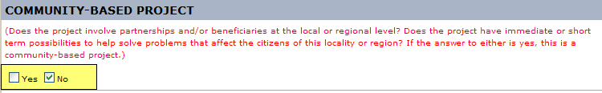
  - Click “Save and Continue”

- Enter Project Investigators (CRAN Level only – this is auto-populated for PIs)
  - Add the Principal Investigator by clicking “ADD PI.”
    - The PI can be added by GEMS ID (Employee ID) or his or her USF email address. Click “Add PI.”
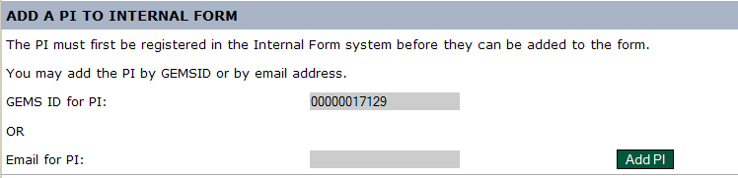
    - Review and click “Confirm.”
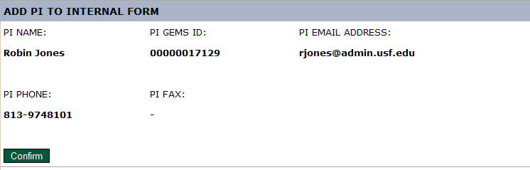
  - If there are Co-PIs or Senior Staff (Key Personnel), select the option under “Project Investigators” located on the beige column on the left side of the screen.
    - Co-PIs can be added by GEMS ID (Employee ID) or USF email address. Click “Add Co-PI.”
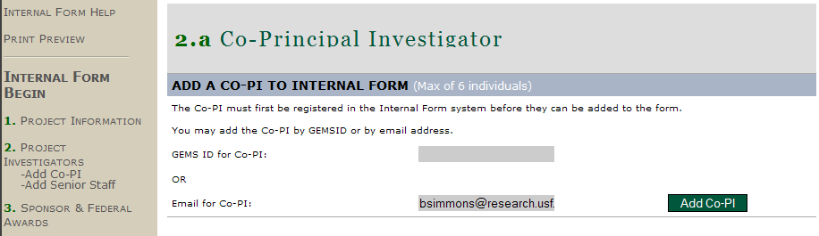

    - Review and click “Confirm.”
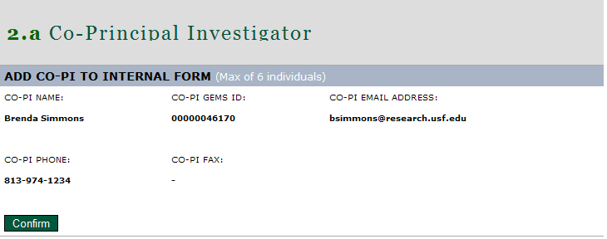
    - A confirmation message is displayed.
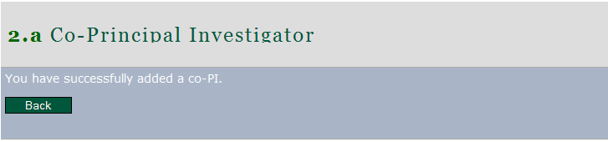
  - Once you have entered any Co-PIs or other Key Personnel, click on Project Investigators to continue. The screen will display the PI with any other key personnel below. Confirm and click “Save and Continue.”
Note: Co-PIs must also be registered to access and sign the Internal Form.
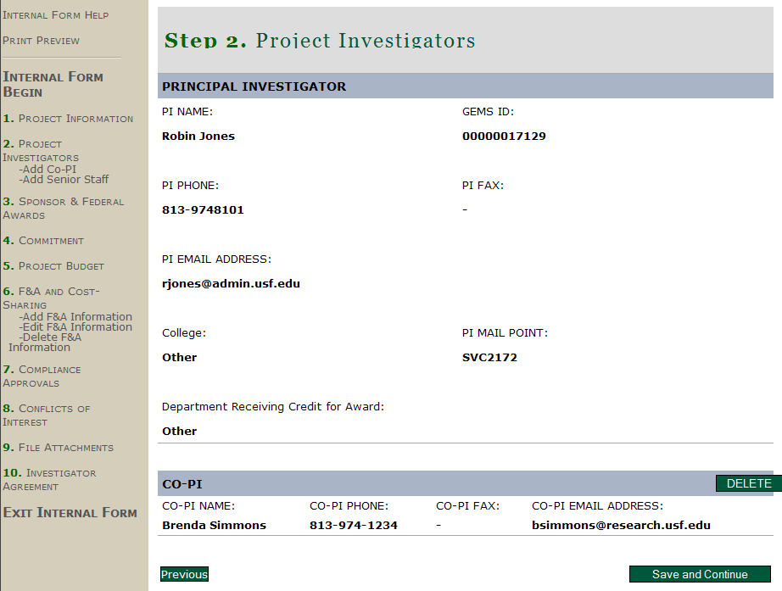
- Sponsor and Federal Awards
  - Sponsor - Enter the following Sponsor information: Name, Program (RFP #, RFA #, or PA#, none, etc), Sponsor Contact name, Sponsor Title (contact’s title), Address, City, State, Zip, Phone, Fax, and Email.
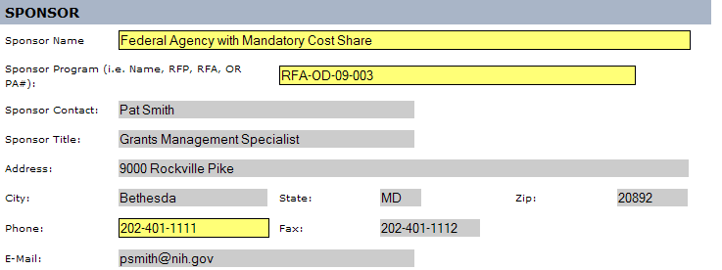

  - Select the Funding Source: Federal, State, Local FL Govt, For Profit Corp, Non-Profit Org, or Other

  - Export Control - Indicate whether Export Control could impact this project. To determine if this applies, ask whether or not the project has an international component through foreign purchases/expenditures, shipping, travel/conferences, subcontracts/consultants, employees/ student/participants, transfer of information or equipment, and/or performance site(s).
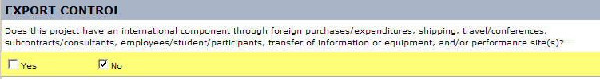

  - CAS Exceptions for Federal and Federal Flow-Through Projects Only - Indicate whether or not the project has Cost Accounting Standards (CAS) exceptions. If your project is federal or federal flow-through but does not have CAS exceptions, select “No.” If your project is federal or federal flow-through and has CAS exceptions, select “Yes.” To determine if this applies, review your budget for any requests for clerical and administrative staff salaries, postage, local telephone services, office supplies, general purpose software/computers/equipment, subscriptions, and/or memberships. If any of those items are requested in the budget, you should select CAS Exception, “Yes” and you must include special justification in the budget narrative in order to comply with federal cost accounting standards (OMB Circular A-21). If your project is not federal or fed flow-through, select “No.” Click “Save and Continue.”
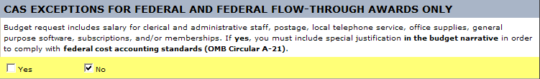

- Commitment
  - Seed Grants - Indicate whether or not the PI has received any seed funds. To determine if this applies, you should consider if you have received an internal grant award from the Office of Research & Innovation, the USF Collaborative, or another USF unit that has substantially contributed to your capacity to write this proposal. If seed funding was received, check “Yes” and indicate the award you received and when. Otherwise, check “No.”
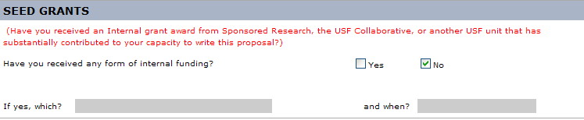

  - University Commitment - Select from one of the three choices to indicate if graduate student stipends/salaries or tuition/fees are requested.
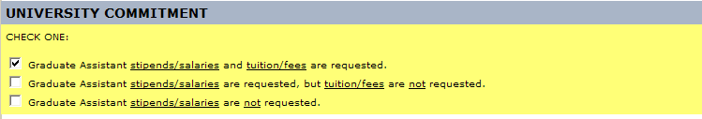

  - Indicate if the budget calls for extra compensation or overload. If any USF faculty or staff will be employed in excess of the full-time equivalent (FTE) established for the employee’s regular or primary, non-OPS position or will be appointed to a non-OPS position and OPS at the same time you will need to check “Yes” for this field and complete the Request for Approval of Extra Compensation form. If not, check “No.”

  - Indicate if this project will involve subcontracts.

  - Indicate if this project requires additional space or facilities. If yes, please provide a description. Click “Save and Continue.”
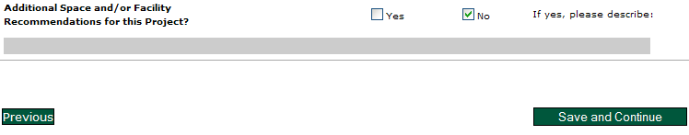

- Project Budget
  - Initial Budget - Enter the budget information for the Initial Budget Period including the start and end dates of the initial budget period, the direct costs (rounded to the nearest dollar), the modified total direct cost (MTDC) or the total direct costs (TDC), and the Indirect Cost (F&A) Rate. To determine what amount to use for MTDC or TDC, please refer to the Facilities and Administrative Cost Rates under “Base.” The green “View Rates” button provides a link to a chart with the indirect cost rates.
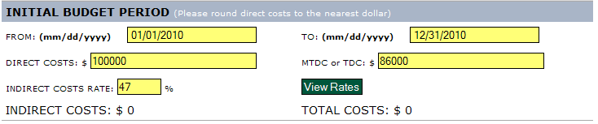

  - Project Period - Enter the budget information for the Project Period including the start and end dates of the entire project period, the direct costs (rounded to the nearest dollar), the MTDC or TDC, and the Indirect Cost Rate. If no indirect costs are allowed, enter a zero in the indirect cost box.
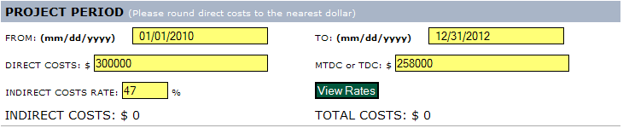

  - Once all fields have been completed, click the “Calculate Costs” button. The indirect cost and total cost should match the proposal budget.
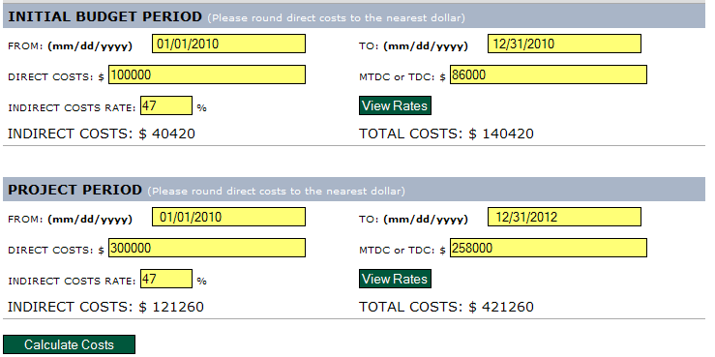
  - Indicate whether or not full indirect costs are being requested. To determine the full indirect cost rate for the project type and funding source, refer to the Facilities and Administrative Cost Rates. If full indirect costs are not requested, indicate why. Click “Save and Continue.”
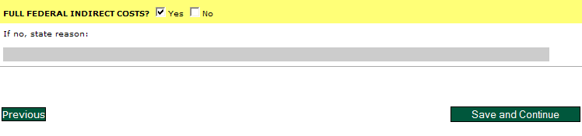

- Distribution of F&A and USF Cost-Sharing
  - Distribution of Facilities and Administration (F&A) - If the PI’s department/college is to receive all F&A, do NOT complete this section. If this project involves the distribution of F&A, click “Add F&A Information” in the beige column on the left side of the screen. For each split in F&A, identify the College or Area, the percentage to be allocated to that area, the PI/Co-PI this distribution applies to, and the Chair’s name.
Note: Only complete this section if F&A is to be shared/split with another department/college.

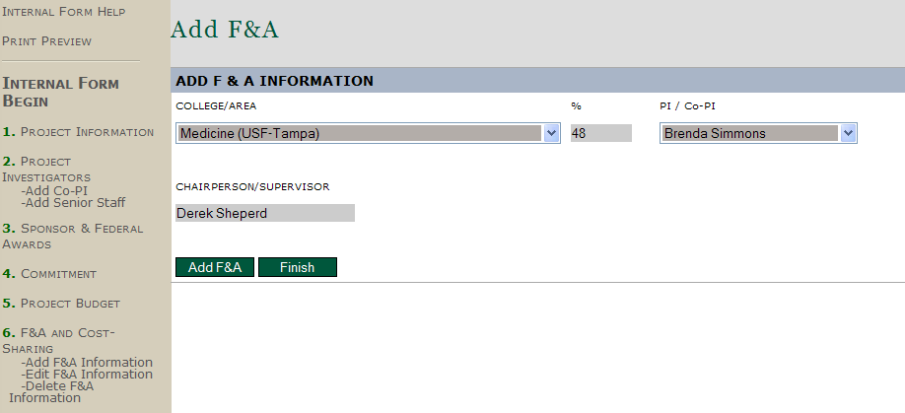
  - Once all fields have been completed for the first distribution, click the “Add F&A” button. Repeat the steps for each distribution. Once all distributions have been added, click “Finish.” The F&A distribution is reflected.
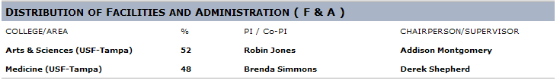
  - USF Cost-Sharing / In-Kind / Match – If no, check the appropriate box and enter a zero in both the required and voluntary boxes then click “Calculate Totals.” All information should be populated with zeroes.
  - If the project includes cost sharing, check the “yes” box and indicate what percentage of required and/or voluntary cost share USF is contributing.

  - If cost sharing is required, input the required percentage in the appropriate field and enter a zero under voluntary. Place the associated cost share dollars in the appropriate categories: Salary, Operating Capital Outlay (OCO), Expenses, and F&A costs. Be sure to place the dollars under the area that will be providing the cost share: the Department, College/Area, DSR and/or 3rd Party.
Note: For 3rd Party, attach written verification from contributor.
  - If voluntary, input the percentage in the appropriate field and enter a zero under required. Place the associated cost share dollars in the appropriate categories: Salary, OCO, Expenses, and F&A costs. Be sure to place the dollars under the area that will be providing the cost share: the Department, College/Area, DSR and/or 3rd Party.
Note: For 3rd Party, attach written verification from contributor.
  - Click “Calculate Totals” to populate the totals fields and verify them against the budget. Then click “Save and Continue.”
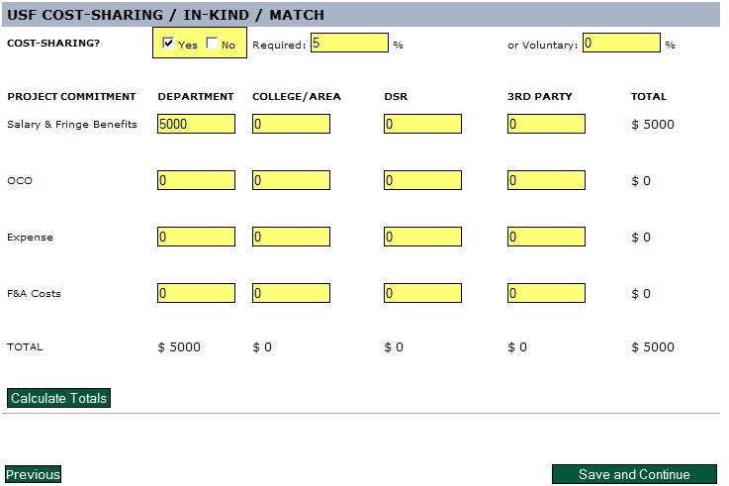

- Compliance Approvals (attach copies of compliance approval letters)
  - Indicate if this project involves:
    - Biohazards (Toxins, Infectious Agents, Recombinant DNA), the Status (approved, closed, exempt, pending), the Approval Date, and Number.
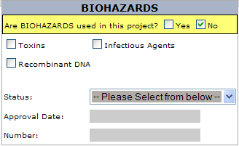

    - Radioactive Materials, the Status (approved, closed, exempt, pending), the Approval Date and Number.
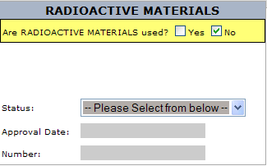

    - Diving Safety
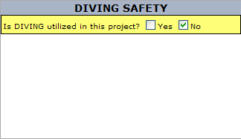

    - Human Subjects (Exempt, Expedited, Full, Outside IRB), the Status (approved, closed, exempt, pending), the Approval Date, and Number.
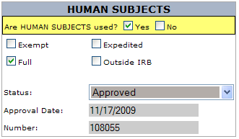

    - Laboratory Animals, the Status (approved, closed, exempt, pending), the Approval Date, and IACUC number. Also indicate whether or not animal data will be used to support a FDA submission.
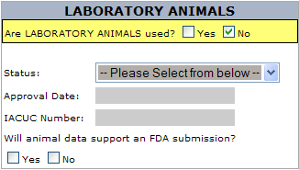

- Conflicts of Interests, Outside Activity, and Nepotism
  - Conflict of Interest Certification - Indicate if any participating faculty, staff, or students (or their spouses or dependent children) have any financial interest such as royalty, equity, or any other payments (e.g., consulting, salary) in the sponsor or other entities having a financial interest in intellectual property, products or services that are the subject of the proposed research. If yes, each participant with a financial interest must complete & submit a Financial Relationships Disclosure Form (FRDF) with this proposal. The FRDF must be approved/signed by the chairperson.
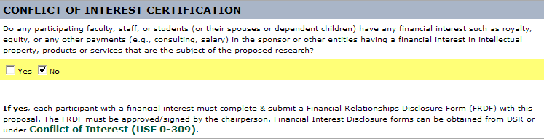
  - Outside Activity - Indicate if there is an outside activity that is or could be perceived as conflicting with this proposed project. If yes, an Outside Activity Form must be attached in the File Attachments section (see below).
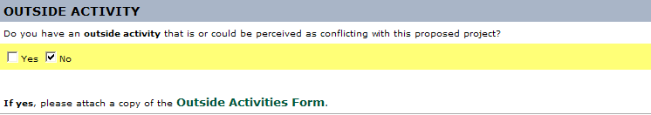
  - Nepotism - Indicate if any participating faculty, staff, or students have any relatives or related persons participating in this proposed research. For definition of relative or related persons, please refer to USF Regulation 6C4-10.107(11). If yes, attach a memo signed by the Provost or Vice President determining how the nepotism has been mitigated. Click “Save and Continue.”
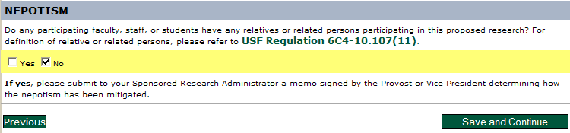

- File Attachments
  - Attach all appropriate files keeping in mind that attachments are not required by the system in order to submit the form but may be required by the department and/or college. Suggestions for items to attach are: budget, budget justification, backup for less than full indirect cost rates, abstract, and compliance approval letters. This is also where forms, such as Financial Disclosure Forms, Outside Activity Forms and Nepotism Memorandums should be uploaded. After uploading, click “Save and Continue.”
Note: Do NOT attach proposal applications or SF424s.
Note: The Internal Form may be modified at any time prior to the PI signature. Once signed, the form is locked and can only be unlocked by the PI or CRAN user.
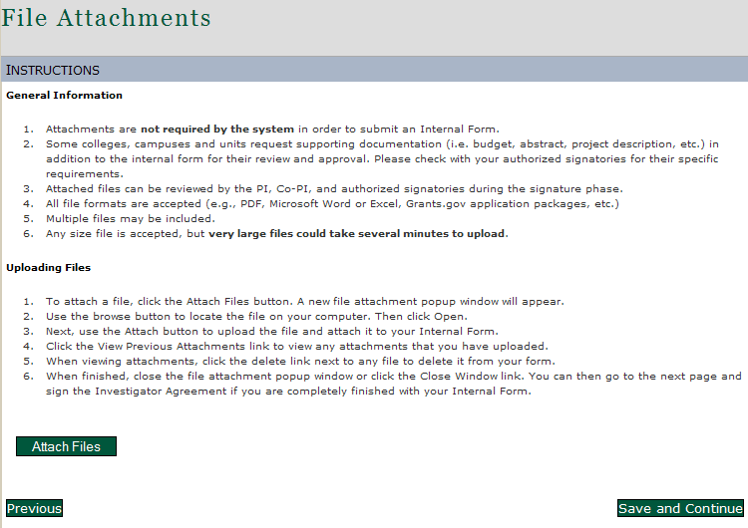

- Investigator Agreement
  - The PI should read the Investigator’s Statement, enter his or her PIN and click “Agree.”
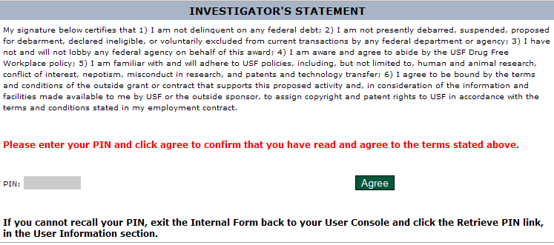
  - If the PI did not complete the Internal Form to this stage, the PI should log into the Internal Form system. From the User Console, the PI should select “Incomplete Existing Forms.” The project title should appear in the list. The PI should click on the name of the project and review all information on the form prior to approval. If any information is incorrect, the PI should consult with his or her research administrator (or whoever completed the form) and make changes where appropriate. After completing the review, the PI should read the Investigator’s Statement and sign the form by entering his or her PIN and clicking “Agree.”
  - Once approve by the PI an auto-generated email notification is sent to the Co-PIs (if any) then the Chair and Dean (or delegates).
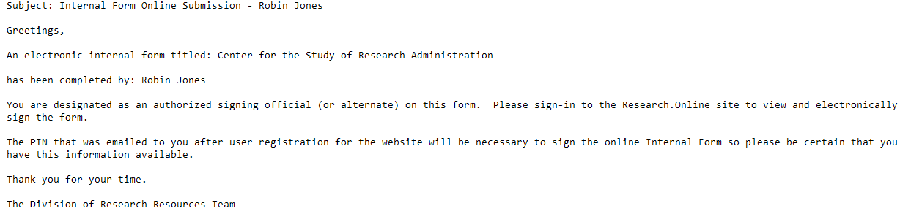
- Checking on the approval status
  - A PI can check on the status of an Internal Form by accessing the Internal Form system and selecting “Complete and Pending Approval” from the User Console. The option will display the level (Co-PI, Chair, Dean) and the status (Pending, Approved, Denied) of each form.
  - If changes are necessary after any signatures have been obtained, the form will need to be unlocked. To do this, the PI or CRAN user should select “Unlock a Completed Form” from the User Console. A “Temporary Withdrawal” email notification that the form has been unlocked will be sent to all who have previously approved the form. Changes can then be made.
Note: The revised form will need to be signed again by all parties.
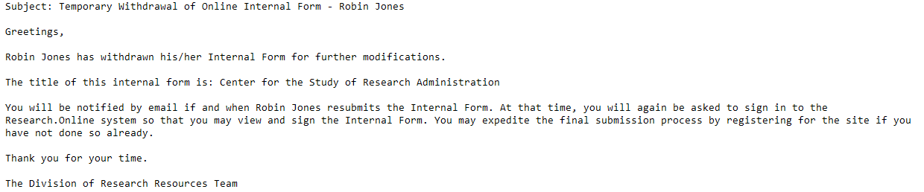
  - Co-PI requests for approval will appear under “Co-Investigator Approval Requests” from the User Console. Co-PIs should review the form, and indicate their intent to participate by electronically signing the agreement.
- Internal Form users may update their user profile, change their password and/or their security question or retrieve their PIN from the User Console.
- CRAN users have additional capabilities/privileges:
  - Department Faculty List displays everyone in the department that has an Internal Form system account, their GEMS ID and Username.
  - Edit Authorized Signatories can be used to modify the Chair and Dean as well as their delegates within the department/college.
  - One cannot be both a CRAN user and a delegate.
- Administrator Access (Chair and/or Dean) have additional capabilities:
  - A PI can be both a faculty user and an Administrator (Chair/Dean/Delegate).
  - Departments can be added, edited or deleted from the Admin User Console.
  - Approval Requests are listed by PI and Title. Checkmarks identify those projects that have less than full F&A, involve cost sharing, and/or a conflict of interest.
  - Chairs, Deans (or Delegates) will not see all of the screens that a PI or CRAN user sees.
  - The Administrator should “Accept” or “Reject” the submission.
    - If it is accepted, click “Accept”, indicate the signing level (PI, Chair, Dean), enter his or her PIN, and click “Submit Decision.”
    - If it is rejected, click “Reject”, complete the rejection comments so that the PI is aware why it is rejected, indicate the signing level (PI, Chair, Dean), enter his or her PIN, and click “Submit Decision.” The PI will be notified that the submission was rejected.
Timelines
The Internal Form should be completed before a proposal is submitted to a sponsor via the Division of Sponsored Research, adhering to the DSR proposal submission guidelines.

Roles & Responsibilities
- Responsible Party: Faculty and/or Research Administrators are responsible for completing the Internal Form. Faculty are responsible for the content listed for their project. The Chair, Dean and/or delegates are responsible for any resources committed by the faculty and for the timely review and approval of forms for their area.
- Workflow: The CRAN and/or PI level enters the information into the Internal Form system. Then the Co-PIs (if any) are automatically notified via email that they need to review and approve the form. After any Co-PIs have approved, the Chair and delegates are automatically notified that they need to review and approve the form. Next, the Dean and delegates are notified that they need to review and approve the form. Finally, the Division of Sponsored Research is automatically notified once the form is fully signed.
- Communications: If the CRAN user starts the form for the PI, he or she needs to let the PI know when the Internal Form is ready for review and signature. After that, the system handles all notifications automatically.

Tools & Training
- Internal Form FAQs
- DSR Website References
- Preparing Proposals and Negotiating Awards

Contacts
- TRAIN® HelpOne, 813-97-HELP1 (813-974-3571)
- Division of Sponsored Research (DSR)

Effective Date or Date Last Updated: June 27, 2011

